P5 Homework
Monday 27th January 2020
Due Friday 31st January 2020
Curriculum Area | Activity
Literacy  Numeracy | Active Spelling:  In class you have chosen your spelling words level from the ‘Chilli Challenge’. You have to find 5 additional words at that level. You may use the internet or a dictionary to help you.  The spelling rule will change every week.  In addition to this, we would like you to practise this rule by choosing to complete two tasks found on the ‘Spelling Menu’. Please choose different ones from last week. Please record your words in your Literacy Homework Jotter and be prepared to share these on Friday. All other tasks do not need to be recorded in the jotter as these should be active and enjoyable and will not be checked over by the teacher.  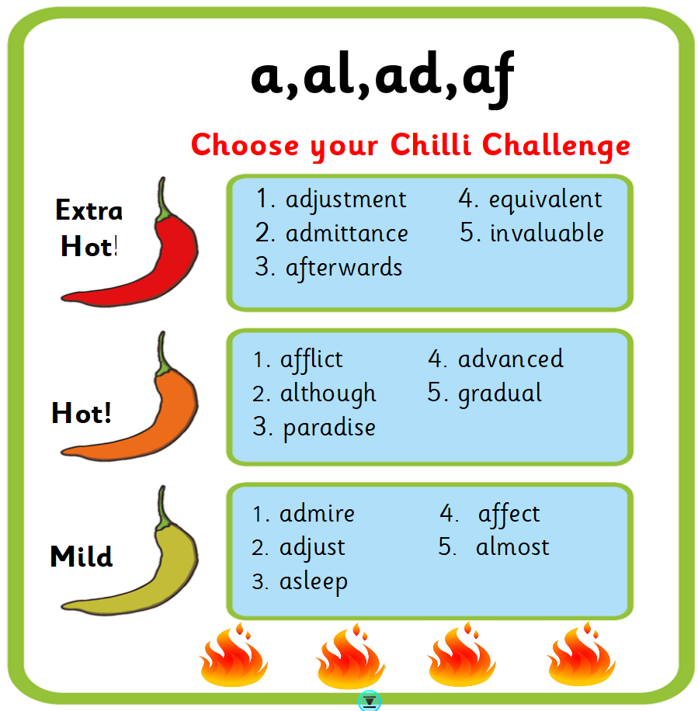  In Numeracy you have been focusing on either number sequences or perimeter and area. Please select any work from the blog that supports your learning.

