Week

- What is the day three days after Wednesday?
- What day is it 2 days before Monday?
- 2 days ago was Thursday. What day is it today?
- 4 days from today, it will be Sunday. What day is it today?
- Yesterday was three days after Saturday. What day is it today?

Month

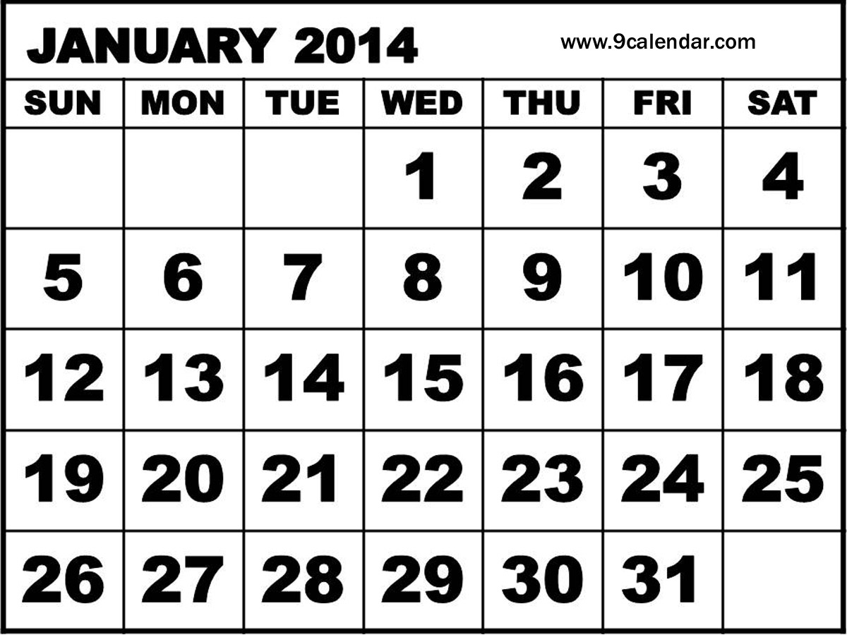

- What day is the 1st day of the month?
- How many days are there in January?
- What day is it two days before 27th January?
- How many full weeks are there in January?
- What is the date one week after 13th January
- Sophie goes on holiday on the 4th January for 10 days. What date does she return?
- Daniel goes on holiday the 2nd Saturday in January. What date did he leave?

Year

- How many days are there in April?
- How many days are there in July?
- How many days are there in October and November combined?
- Paul goes on holiday on 27th January for 7 days. What is the last day of his holiday?

Look at the calendar above
- What day of the week would 19th be?
- What day of the week would 25th be?
- True or false… 26th January falls on a Sunday.
- What is the date one week after Friday 11th?
- What is the last day of the month?
- What was the date on the Sunday before 1st July?

