Primary 6c Homework
Week Beginning Monday 17th February 2020
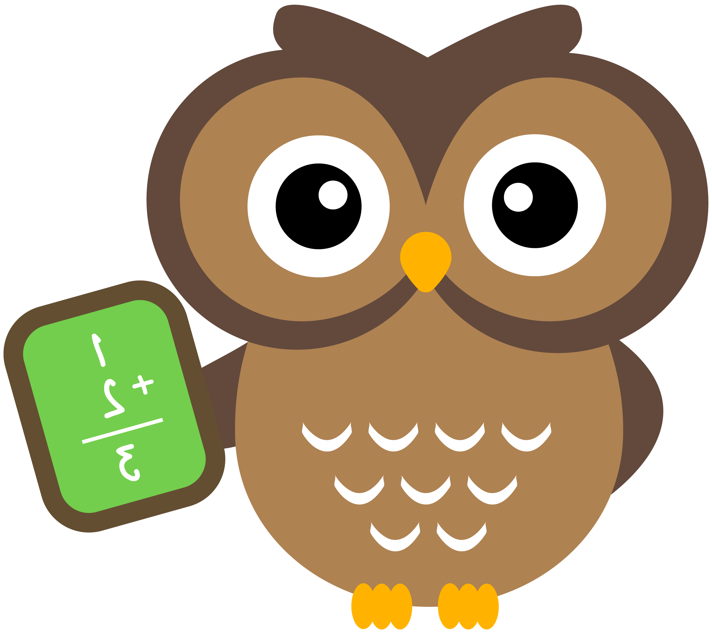


Subject | Task
Numeracy | Mental Maths  Archimedes – D1/2  Fibonacci – C6/2  Pythagoras – C2/2  Please answer the questions mentally with an adult. You do not need to write the answers in your jotter.
Literacy | Spelling  This week’s rule: soft c  Choose one or two active spelling strategies to help you learn this week’s rule.  Spelling City  https://www.spellingcity.com/users/Primary6Kirkhill  Click on the link above to access this week’s chilli challenge spelling words. You are welcome to try all 3 levels but make sure you focus on the level of challenge you have selected this week.
Context | Health and Wellbeing – Kindness  We have been talking about positive mental health and what it means to be kind in school over the past few weeks. Can you think of a small act of kindness you could do for another person this week? This could be a friend, family member or even someone in your local community.  You can share your ideas on Seesaw if you want to ☺

Please return all homework activities and your homework diary, signed by a parent, by Friday 21st February 2020.

