Primary 6c Homework
Week Beginning Monday 16th September 2019

Subject | Task
Numeracy   | Mental Maths  Archimedes – C4/3  Fibonacci – C3/3  Pythagoras – B9/3  Please answer the questions mentally with an adult. You do not need to write the answers in your jotter.
Literacy   | Spelling  This week’s rule: word roots – act/port/scri  Choose one or two active spelling strategies to help you learn this week’s rule.  Spelling City  https://www.spellingcity.com/users/Primary6Kirkhill  Click on the link above to access this week’s chilli challenge spelling words. You are welcome to try all 3 levels but make sure you focus on the level of challenge you have selected this week.
Context   | Topic – Natural Disasters  Please refer to the topic grid in the files section on Microsoft Teams. Choose one activity.  OR  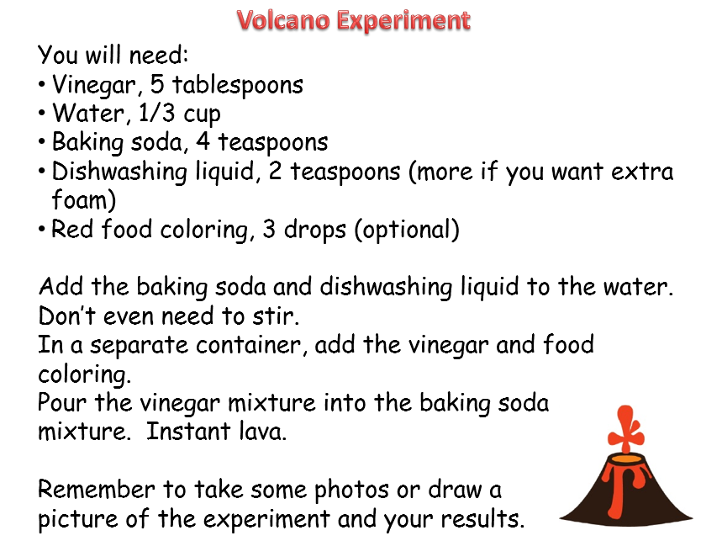

Please return all homework activities and your homework diary, signed by a parent, by Friday 20th September 2019.

