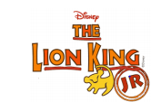

AUDITION MATERIALS

Thank you for your interest in the upcoming production of Lion King Jr. We have had over 170 applications to take part in our show! WOW! With only 70 parts available, we have a very tough job ahead of us!
Please don’t be disappointed if you are not chosen for this particular show, we have plenty of other productions in the coming years that you can take part in!
It takes a very confident person to audition in front of their class, and the fact you have chosen to audition is a huge achievement in itself! #PROUD

You will find information on the parts you can audition for below. Auditions will take place in your own class over the next two weeks. Pupils who are being considered for a main part may be asked to attend a second audition.

Good Luck!

Speaking parts
As this is a musical, all speaking parts also require singing on stage. Therefore, to audition for a speaking part in the show please prepare ONE acting piece from the dialogue below and ONE song. This song can be sung on your own or with other people in your class. You do not need to learn dialogue or song words off by heart for the audition.

Main Character parts
If you are in Primary 4-6 and would like to audition for a main part please prepare ONE acting piece from the dialogue below and ONE song. This must be performed as a solo.

Dancers
Please feel free to prepare a short dance of your choice to showcase your talents. This dance does not have to be from The Lion King.

Musicians
Please prepare a piece of your choice on any musical instrument. This does not have to be a piece of music from The Lion King but you can find sheet music on page 3 for anyone who wishes to use this.

You may wish to read the character summary below before preparing your audition. Think about how the character would deliver these lines!

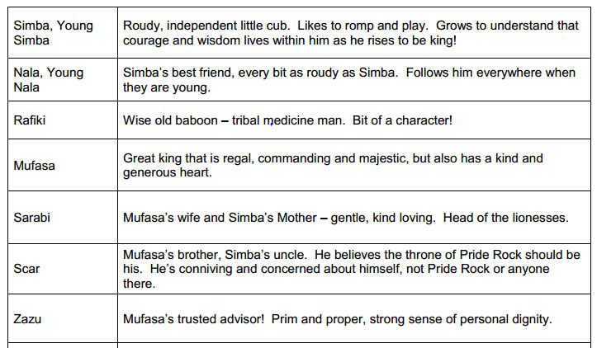
Character Summary

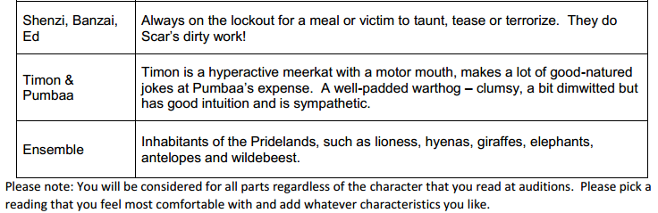

Dialogue 1
MUFASA - Scar! Sarabi and I didn’t see you at the presentation of Simba.
SCAR – That was today? Oh dear I feel simply awful, it must have… slipped my mind.
MUFASA – As the Kings brother, you should have been first in line.
SCAR – I was first in line until that little hairball was born!
MUFASA – That hairball is my son and your future King!
SCAR – Oh, perhaps I shall practise my curtsy. (turns away)
MUFASA – Don’t turn your back on me Scar!
SCAR – Oh no Mufasa, perhaps it is you who shouldn’t turn your back on me!
MUFASA – Is that a threat? (turning aggressively)
SCAR – (backing off) Temper, temper. I wouldn’t dream of threatening you. I got the Lion share of brains, but when it comes to brute strength, I’m in the shallow end of the gene pool. (walks away and exits)

Dialogue 2
Simba – Alright we lost him I’m a genius!
Nala – This is it we made it! Its, really creepy.
Simba – Yeah, Isn’t it great?
Nala – We could get in big trouble. This is waaay beyond the boundary of the pridelands it’s very dangerous, we must leave!
Simba – Danger? Ha! I walk on the wild side. I laugh in the face of danger ha-ha-ha. They can’t do anything to me! I’m gonna be king some day!

Dialogue 3
PUMBAA – oh hey Timon you better come and have a look at this, I think its still alive
TIMON- YIKES! It’s a lion! Run Pumbaa! Move it!
PUMBAA – aww Timon, look at him. He’s so cute and all alone. Can we keep him?
TIMON – Are you nuts? You’re talking about a LION! Lions eat guys like us!
PUMBAA – but he’s so little
TIMON – but he’ll get bigger!
PUMBAA – Maybe he’ll be on our side?
TIMON – That’s the stupidest thing I ever heard… Hey I’ve got it, what if he was on our side? Ya know having a lion around may not be such a bad idea. – You okay kid? (poking simba)

Song 1
“Can You Feel the Love Tonight”
https://www.youtube.com/watch?v=YU5W0rlsAmI
(Chorus)
Can you feel the love tonight
The peace the evening brings
The world for once in perfect harmony
With all its living things

Song 2
“I Just Can’t Wait To Be King”
https://www.youtube.com/watch?v=YHp_W45Xlgw

I'm gonna be a mighty king, so enemies beware! (I've never seen a king of beasts with quite so little hair)
I'm gonna be the mane event
Like no king was before
I'm brushing up on looking down
I'm working on my roar
Oh, I just can't wait to be king!

