Numeracy | Out and About! | Literacy
- Research Kings and Queens of the past. Create a bar chart to compare the length of Queen Victoria’s reign with reign of other Kings  and Queens.  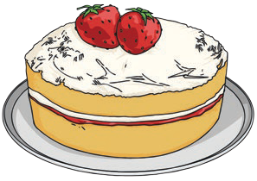  - Measure out ingredients to make a Victoria sponge.  - Compare coins from the Victorian era with coins from today. Are there any differences/similarities? | - Create an outdoor game that children could have played in the  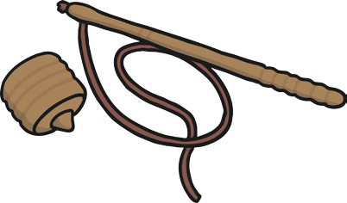  Victorian times.  - Go to your local library  and find some non-fiction books  about the Victorians. | 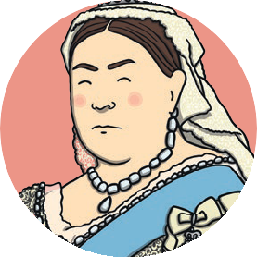  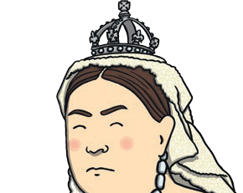  - Write an acrostic poem for Victorians.  - Research and write 10 facts about Queen Victoria.  - Write a letter to Charles Darwin explaining why it is important that your favourite animal doesn’t become extinct.  - Read a novel either based in or  written in Victorian times.
Working with Others | Homework Choice Grid  Victorians | 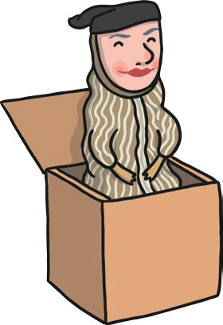  Expressive Arts
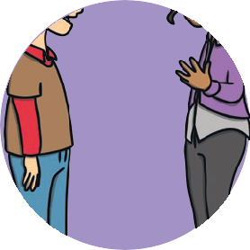  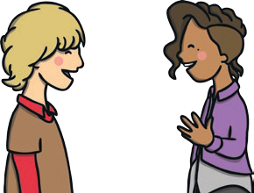  - With help from a friend or family member, create a family tree for Queen Victoria.  - Design and play a Victorian themed board or card game.  - Make up a Victorian Quiz and test your family  and friends. | Homework Choice Grid  Victorians | - Design a stamp.  - Paint or draw a Victorian scene.  - Research and create a fact file of a famous Victorian artist.  - Design your own toy for a Victorian child.
Technology and Science | Health and Wellbeing | 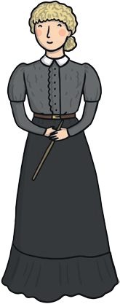  Social Studies
- Draw/trace two different types of  Victorian transport and compare.  - Write a list of at least 5 things invented during the Victorian era.  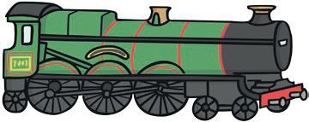  - Create a list of items which we use now which were also used by Victorians. | 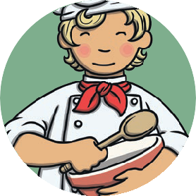  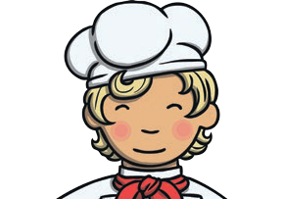  - Design a Victorian themed menu. Think about types of food which they ate.  - If you were Queen Victoria, what new laws would you pass? | - Research different types of transport  people used in Victorian times and compare with today.  - Draw or trace a world map. Mark the countries which were part of the British Empire.  - Compare a Victorian school day with one today.

