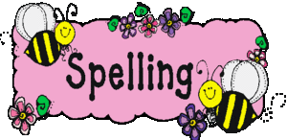Spelling Challenges! 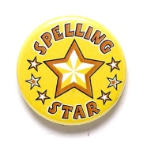
Picture  Draw and colour a picture. Hide your spelling words inside. | Spelling Poem  Write a poem using several of your spelling words. | . Make the Headlines  Cut letters out of newspapers  or magazines and stick them  onto paper to make the words  in your list. | Magazine words.  Find letters in an old magazine that make your words. Cut and stick into your jotter. | Acrostic Poem  Write your spelling words vertically and create an acrostic poem. | Spelling flowers  Draw a flower for each word. Write the letters on each petal. | Fancy letters  Write each of your spelling words using fancy letters. | Consonant Circle  Write each of your  spelling words then  circle all of the  consonants.
Words Without Vowels  Write your spelling words on a list but replace the vowels with a line. Now see if you can fill in the blanks. | Build a Pyramid  Make a pyramid using the letters  in your words.  w  wo  wor  word  words | ABC Order  Write your spelling words in alphabetical order. | Capital Idea  Write your words three times,  each in capital letters. | Silly Sentences  Write a silly sentence for each spelling word. | 3-D Words  Use plastercine to create your spelling words | Wordsearch  Create a wordsearch for a friend to complete. | Rainbow Writing  Write your spelling words in three different colours.  (Remember to write them on top of each other to create a rainbow)
Bubble Letters  Write your words in bubble letters. | Shapes  Write each word and draw around it. Study the shape to help you remember. | Speed Challenge  Using a timer, try and write each spelling word in turn as many times as you can in 30 seconds. | Can you guess?  With a partner write a spelling word gently on their back using your finger as a pencil. Can they figure out what the word is? | Taboo  Write a clue about each of your spelling words. Find a partner and test if they can spell the word from your clues. | Create with Colour  Write your words with each letter  in a different colour, or write  them with all the vowels in blue  and all the consonants in red.  spelling  spelling | Dictionary Skills  Write out your spelling words and the dictionary definition for each. | Giggles!  Write some jokes using as many of your spelling words as you can. Share with a partner for a giggle!

