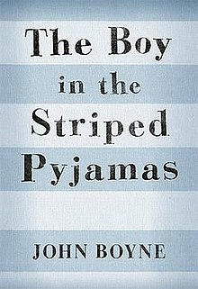
The Boy in the Striped Pyjamas Homework Project
For this 2 week homework project, please complete activities on the grid which add up to 40 points.
Research John Boyne and create a fact file.  10 Points | Create a model from a scene in the story which stood out to you.  20 points | Write a diary entry as Bruno from any point in the story.  10 points | Write a diary entry as Schmuel from any point in the story.  10 points | Design a floor plan for Bruno’s new house at Outwith.  10 points
Create a new front cover for the book.  10 points | Create a board game based on the book so far.  20 points | Create a wordsearch using key words from the story.  10 points | Cast a film version of the story with famous actors and give your reasons.  10 points | Turn a chapter into a script.  20 points
Create a reading journal of your thoughts and feelings as we read.  20 points | Create a film trailer- storyboard it or act it out.  20 points | Create a comic strip of one chapter with pictures and key events.  10 points | Record a voice reading of a part of the story which stood out to you.  20 points | Design a face mask to show the inner feelings of a character.  20 points
Create an annotated drawing for 2 of the characters.  10 points | Write an alternative ending for a chapter you have read.  10 points | Design costumes for 2 or more of the characters. Present this through a method of your choice.  20 points | Write a diary entry as Father from any point in the story.  10 points | An activity of your choice (with approval from your teacher).

