The Marvellous, Mighty, Monster Truck!
50% OFF FOR A LIMITED TIME!
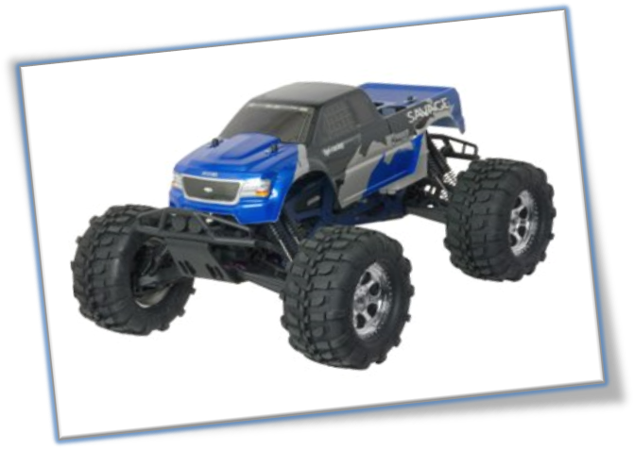
HURRY! WHILE STOCKS LAST!
VOTED BEST TOY OF 2018

Children, are you fed up with your toys breaking?
Are you looking for a new fantastic unbreakable monster truck?
Well look no further, help is here with the indestructible, Marvellous, Mighty, Monster Truck here just for YOU!
The Mighty Monster truck is like no other truck that has ever been seen before!
It has an all-new exceptional and electrifying design! This toy is for YOU; it will be a superb, special and sensational addition to YOUR toy collection!
The Mighty Monster truck has many breakthrough and breath-taking features including:
- It’s mind-bogglingly huge wheels (monster truck will be able to go everywhere YOU go),
- Remarkably responsive, smooth suspension, (so your monster truck will not be damaged by any bumps),
- An everlasting body kit made out of robust rubber, (so your monster truck can survive any collision that may occur),
- Remarkable voice recognition technology, (which allows you to control your monster truck by telling it were you want it to go as it responds to 25 programmable commands),
- Incredibly interesting and entertaining, (your monster truck will keep you entertained for hours and hours and will make you popular with your friends!)
Let the Marvellous, Mighty, Monster Truck join your toy box today and you’ll have the privilege of owning the most amazingly mind-blowing Monster Truck there ever will be!
Miss it! Miss out!

