P7 Show 2019
Speaking/Singing Auditions
Dialogue 1
BELLE: Papa? Papa? Hello? Is someone here? Wait! I'm looking for my father. That's funny, I'm sure there was...
MAURICE: Belle?
BELLE: Oh, Papa! Oh, your hands are like ice. We have to get you out of here.
MAURICE: Belle, I want you to leave this place.
BELLE: Who's done this to you?
MAURICE: No time to explain. You must go...now!
BELLE: I won't leave you!
BEAST: What are you doing here?
MAURICE: Run, Belle!
BELLE: Who's there? Who are you?
BEAST: The master of this castle.
BELLE: I've come for my father. Please let him out! Can't you see he's sick?
BEAST: Then he shouldn't have trespassed here.
BELLE: But he could die. Please, I'll do anything!
BEAST: There's nothing you can do. He's my prisoner.
BELLE: Oh, there must be some way I can...wait! Take me, instead!
BEAST: You! You would take his place?
MAURICE: Belle! No! You don't know what you're doing!
BELLE: If I did, would you let him go?
BEAST: Yes, but you must promise to stay here forever.
BELLE: Come into the light. (gasps)
BELLE: You have my word.
BEAST: (quickly) Done!

Dialogue 2
COGSWORTH: Couldn't keep quiet, could we. Just had to invite him to stay, didn't we? Serve him tea, sit in the master's
Chair, pet the pooch!
LUMIERE: I was trying to be hospitable!

LUMIERE: Shhh! Did you see that? It's a girl!
COGSWORTH: Yes, I know it's a girl Lumiere.
LUMIERE: Don't you see? She's the one. The girl we have been waiting for… She has come to break the spell!
‘Belle’
Little town, it's a quiet village. Every day like the one before
Little town, full of little people. Waking up to say [ENSEMBLE:] Bonjour! Bonjour! Bonjour! Bonjour! Bonjour!
There goes the baker with his tray, like always. The same old bread and rolls to sell
Every morning just the same. Since the morning that we came
To this poor, provincial town (Good Morning Belle)
Aaah, isn't this amazing?
It's my favourite part because—you'll see
Here's where she meets Prince Charming
But she won't discover that it's him 'til Chapter Three!

‘Be Our Guest’
And now, we invite you to relax, Let us pull up a chair
As the dining room proudly presents - Your dinner!
Be our guest! Be our guest!
Put our service to the test
Tie your napkin 'round your neck, Cherie. And we'll provide the rest
Soup du jour. Hot hors d'oeuvres
Why, we only live to serve
Try the grey stuff - It's delicious!
Don't believe me? Ask the dishes
They can sing, They can dance,
After all, Miss, this is France!
And the dinner here is never, never second best!
Go on, unfold your menu
Go on, take a glance and then you'll
Be our guest, Oui, our guest. Be our guest!

‘Gaston’
Gosh it disturbs me to see you, Gaston. Looking so down in the dumps
Every guy here'd love to be you, Gaston. Even when taking your lumps
There's no man in town as admired as you. You're everyone’s favourite guy
Everyone’s awed and inspired by you. And it's not very hard to see why…

No one's slick as Gaston. No one's quick as Gaston
No one's neck's as incredibly thick as Gaston's
For there's no man in town half as manly
Perfect, a pure paragon!
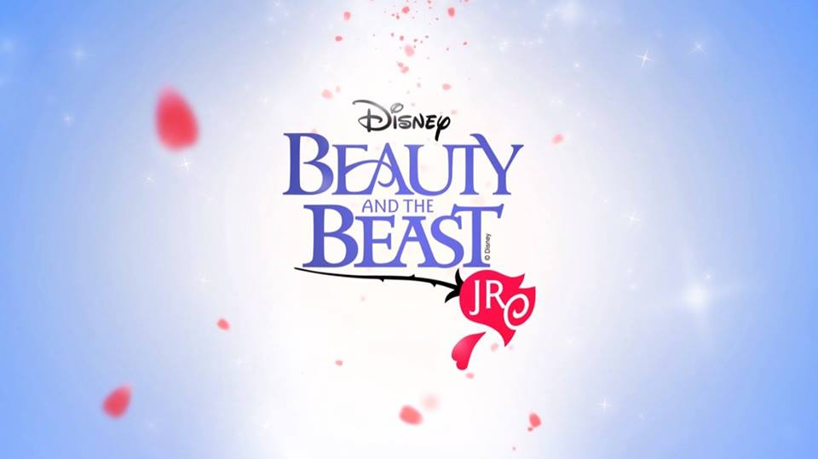
You can ask any Tom, Dick or Stanley
And they'll tell you whose team they prefer to be on

No one's been like Gaston. A king pin like Gaston
No one's got a swell cleft in his chin like Gaston
As a specimen, yes, I'm intimidating!
My what a guy, that Gaston!

