Date of Notification & Method |  | Source of notification  Source contact and tel. number
Family member name |  | Relationship | Mother  Father  Carer  Kinship carer  Other (please state) | Age | 12 – 17 years  18 – 24 years  25 – 34 years  35 – 44 years  45 – 54 years  55 – 64 years |  | Ethnic Origin | White  Mixed or multiple ethnic group  Asian/Asian Scottish/Asian British  African  Caribbean or black  Other
Contact number
Address (Inc. postcode)
Email address
Youngest Child Name |  | DOB: |  | Siblings |  |  | DOB
School/Nursery attend |  |  |  | Agencies involved at present
 |  |  |  | Named Health Visitor
Summary of concern: ( in one sentence)
Anticipated support from FF?
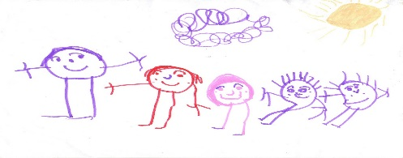
Parent has given consent (please tick)
Family First

