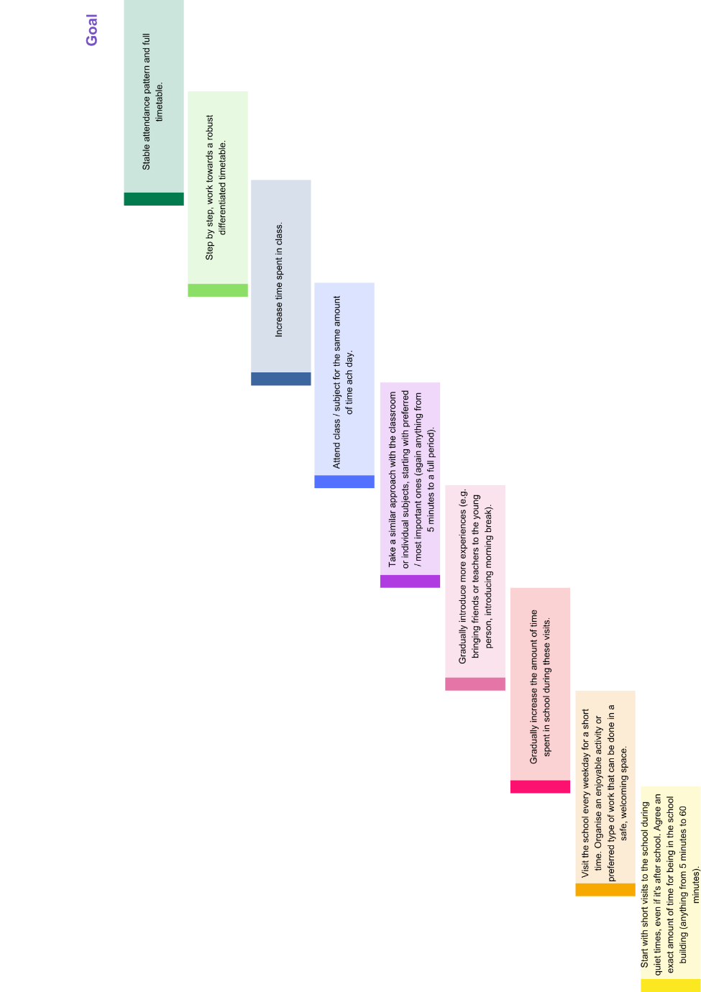

Figure Twelve: Graded Exposure - Simple Example