Dear Parent/Carer,

Regular school attendance offers your child the best possible start in life and helps to prepare them for the world of work. School is not just about exams, it’s about developing talents and abilities that allow your child to fulfill their potential and to follow their dreams whatever they might be.
In Barrhead High School our teachers work extremely hard to create and deliver exciting lessons and opportunities to ensure your child is included, engaged and involved in school life. Like you, we want your child to be aspirational about the future. It is no surprise that the more your child attends school the more likely they are to achieve their potential, and thrive in their future.
The graph below, based on local authority data, demonstrates that there is a clear link between school attendance and the average number of National 5 awards attained.
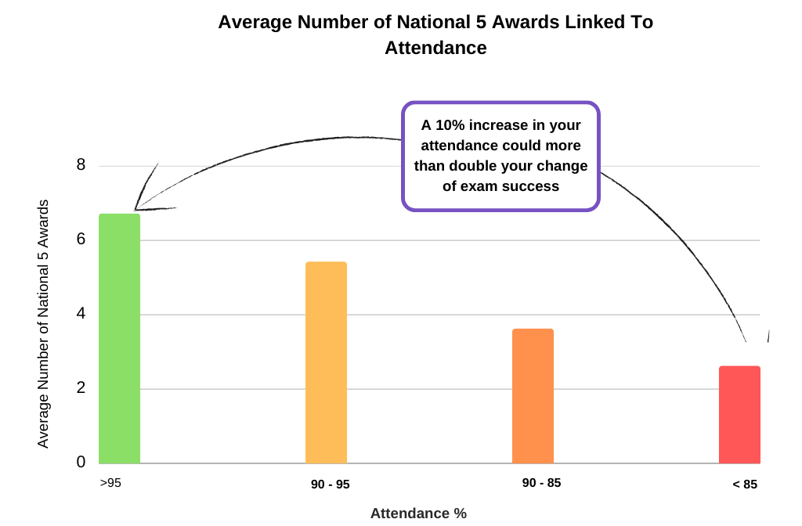

Your child’s attendance to date for this session is X%. Could they improve on this? If so it’s never too late to make a difference. If you are concerned about your child’s attendance please do not hesitate to contact their pastoral care teacher. They will be happy to discuss ways to help you and your child improve their attendance and help you to set short term targets that can lead to long term improvements.

