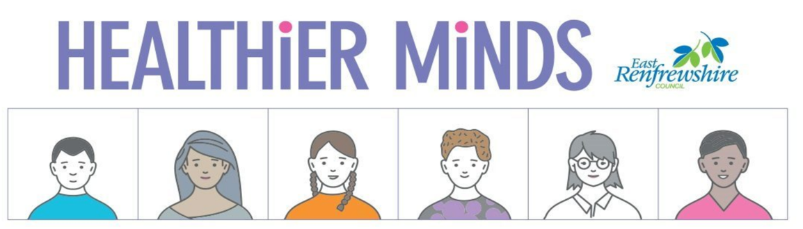
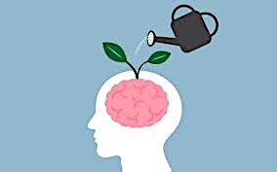

Mindfulness
The awareness that emerges through paying attention on purpose, in the present moment, and nonjudgmentally to the unfolding of experiences moment by moment” (Kabat-Zinn, 2003, pg 145)

This summer, the Healthier Minds team are offering a 6 week introduction to mindfulness approaches for parents. The course will focus on bringing a mindful awareness to our daily lives and cultivating a loving kindness towards ourselves and others. This will be done through a balance of formal practices (such as body scan, movement and meditation) and informal discussion as part of a small supportive group.
Classes will be delivered via Teams with the potential for some face to face sessions as restrictions change. Classes will run from 9am-11am on the following dates:
Classes will be delivered via Teams with the potential for some face to face sessions as restrictions change. Classes will run from 9am-11am on the following dates:

Thursday 15th July
Thursday 22nd July
Thursday 29th July
Thursday 5th August
Thursday 12th August
Thursday 19th August

There are limited spaces. Therefore, if you are interested in joining this course please complete the following form as early as possible.
If you have any questions please contact Siobhan Drummond
ps@eastrenfrewshire.gov.uk
0141 577 8510

Contact Information

Name
Phone number
Email address
Please tell us about what you hope to gain from attending this course?

Is there anything you would like the facilitators to know in advance of attending?

