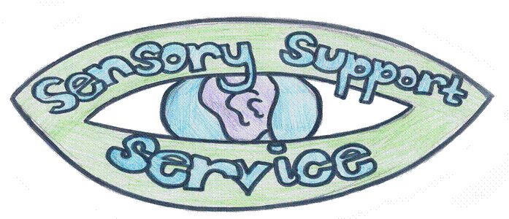

**Making videos accessible for pupils with hearing loss**

* Ensure good lighting
* Sit close enough to camera so that your lip patterns are clear
* No bright lights or windows behind you as your face will be in shadow
* Use a microphone when recording. Often the microphone on laptops/tablets do not provide clear speech.
* Speak clearly at a normal pace. Not too fast, not too slow.
* Make full use of facial expression/gesture.
* Use visuals to increase understanding but be wary of speaking at the same time if your lip patterns are not on screen.
* Recap main points in text
* Add subtitles – ideally not using auto-generated unless errors are corrected

**Adding subtitles to video clips**

Auto-generated subtitles often have errors, especially when subject specific vocabulary is used. Pupils without that knowledge of language may not be able to identify or correct these errors when reading, resulting in misunderstanding of the content.

The following software/sites can be used to add subtitles:

* MSTeams – export to Stream which allows to add subtitle  
  <https://docs.microsoft.com/en-us/stream/portal-add-subtitles-captions>
* MSTeams – use auto-captioning for live meetings  
  <https://support.microsoft.com/en-gb/office/use-live-captions-in-a-teams-meeting-4be2d304-f675-4b57-8347-cbd000a21260>
* Adobe Spark  
  <https://spark.adobe.com/make/videos/add-subtitle/>
* Kapwing – free for up to 7 minutes of film. Can upload link to existing video.   
  <https://www.kapwing.com/tools/caption-video>  
  <https://www.kapwing.com/subtitles>
* YouTube – allows you to edit auto-generated subtitles  
  <https://support.google.com/youtube/answer/2734705?hl=en-GB>
* iMovie – Apple based  
  http://www.smc.edu/StudentServices/DisabilityResources/Pages/Captioning-in-IMovie.aspx
* Otter.ai  
  <https://blog.otter.ai/video-captions/>
* MixCaption Apple based app – auto and manual transcription  
  <https://apps.apple.com/us/app/mixcaptions-video-subtitles/id952426779>
* Amara – online tool  
  https://amara.org/en