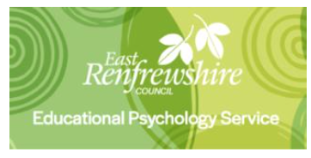
Mental Health and Wellbeing Supports

Websites
- Healthier Minds is East Renfrewshire’s guide to promote the mental wellbeing of children and young people. The aim of this resource is to help parents, carers and practitioner’s support children and young people to meet life’s challenges, develop their resilience and have a healthier mind as a result. There are different strategies, activities and signposting to promote wellbeing. There is also a new ‘Talking about Covid-19’ page which parents can use to support their family’s wellbeing during this difficult time.
  - https://blogs.glowscotland.org.uk/er/healthierminds/
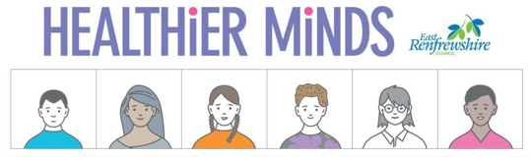

- Mind is a website that provides practical advice, support and guidance on a range of topics including: mental health, wellbeing, coronavirus, and ways to support others.
  - https://www.mind.org.uk/information-support/coronavirus/coronavirus-and-your-wellbeing/

- Heads Together is a mental health initiative that aims to tackle the stigma and change the conversations about mental health. On their website, there is a wide range of useful resources and helplines to help you support your own and others mental health and wellbeing.
  - https://blogs.glowscotland.org.uk/er/public/healthierminds/uploads/sites/18270/2020/03/25153155/coronavirus-mental-health-and-wellbeing-resources.pdf
  - https://www.headstogether.org.uk/coronavirus-and-your-mental-health/

- Young Minds is a charity dedicated to children and young people’s mental health. This website is continually updated with relevant articles, resources and guides for children and young people. There are also resources available to help caregivers support children and young people.
  - https://youngminds.org.uk/

Support
- Parent Club is a Scottish support system where different ideas, tips and resources are posted to support parents.
  - https://www.parentclub.scot/topics/health/coronavirus?age=0

- Young Minds run a Parents Helpline at 08088025544, free Mon-Fri from 9.30am to 4pm and an email service at https://youngminds.org.uk/contact-us/parents-helpline-enquiries/.
  - https://youngminds.org.uk/find-help/for-parents/parents-helpline/

- Campaign Against Living Miserably (CALM): offer accredited, confidential and free support to men anywhere in the UK through a helpline and a webchat service. They will talk through any issue with you and offer support, advice and signposting. Calls won’t show up on your phone bill and are free on all phones.
  - https://www.thecalmzone.net/help/get-help/

Programmes
- Living Life to the Full: free online courses covering low mood, stress and resiliency. Work out why you feel as you do, how to tackle problems, build confidence, get going again, feel happier, stay calm, tackle upsetting thinking and more. This course is currently being offered for free online.
  - Adult course: https://llttf.com/corona/
  - Children and Young People’s course: https://llttfyp.com/corona/
  - https://llttf.com/

- Mood Juice is a website run by the NHS to help you think about emotional problems and work towards solving them with a series of self-help guides for depression, low mood and anger.
  - https://www.moodjuice.scot.nhs.uk/mildmoderate/entry.asp

Family Wellbeing
- Parenting Across Scotland have produced a list of ideas for looking after your mental and physical health and wellbeing as a family.
  - https://www.parentingacrossscotland.org/info-for-families/coronavirus/looking-after-yourself-and-your-family/

Self-Care
- Anne Freud National Centre for Children and Families have posted 91 different ideas for children, young people and adults to help them help themselves.
  - https://www.annafreud.org/selfcare/

- Headspace is a self-help app that provides sets of guided meditations aimed at tackling problems related to anxiety, sleep and relationships.
  - https://www.headspace.com/

Bereavement
- On the Healthier Minds website, there is a section dedicated to a parents, professionals, children and young person’s Guide to Bereavement, Loss and Grief.
  - https://blogs.glowscotland.org.uk/er/healthierminds/bereavement/
  - https://blogs.glowscotland.org.uk/er/public/healthierminds/uploads/sites/18270/2020/04/14153715/Bereavement-Loss-and-Grief-COVID-19-Where-to-Find-Help.pdf

- In this guide, there are links, phone numbers and websites to different organisations that offer support. It includes information on: confidential help, preparing for and following a bereavement and those affected by a life limiting or life shortening illness.
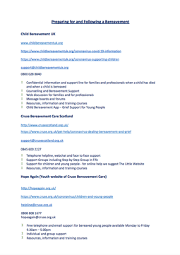
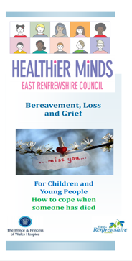
  - https://blogs.glowscotland.org.uk/er/public/healthierminds/uploads/sites/18270/2020/04/14153715/Bereavement-Loss-and-Grief-COVID-19-Where-to-Find-Help.pdf
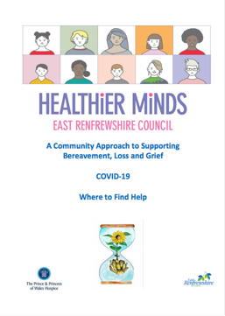

Helpful Phone Numbers
- Heads Up: has information on self-harm and suicide and includes advice and tips on ways on how people can cope and get help. http://headsup.scot/

- LifeSIGNS: Self injury guidance and support network. http://www.lifesigns.org.uk/

- Samaritans: 116 123. A free and confidential support to anyone, any age.

- Breathing Space: 0800 83 85 87. A free confidential phone and web based service for people experiencing low mood, depression or anxiety. Mon-Thurs 6pm – 2pm and weekends Friday 6pm to Monday 6am
Bereavement
- Cruise Scotland: Offering a telephone helpline, webchat and face to face support to those who have experienced bereavement, loss and grief. Call 0845 600 2227 or email support@crusescotland.org.uk

- Winston’s Wish: is a charity dedicated to supporting children and young people after the death of a parent or sibling. They offer: a telephone helpline 8088 020 021 and online messaging service https://www.winstonswish.org/coronavirus/

