[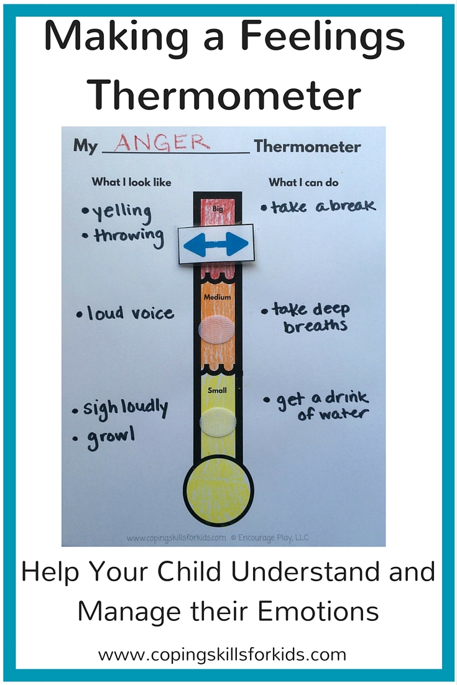](https://www.google.co.uk/url?sa=i&rct=j&q=&esrc=s&source=images&cd=&cad=rja&uact=8&ved=2ahUKEwi_kq-whMHiAhV06uAKHU8SCUIQjRx6BAgBEAU&url=https://copingskillsforkids.com/blog/2016/4/27/making-a-feelings-thermometer&psig=AOvVaw3yDe1XqdVmv2iJE5uU0tdK&ust=1559229203177787)

[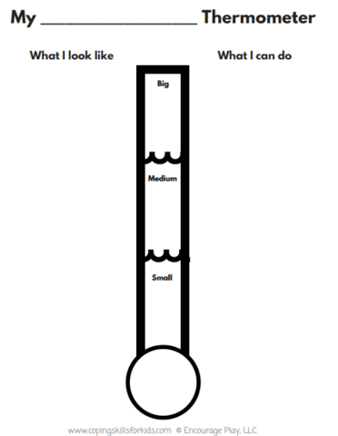](https://www.google.co.uk/url?sa=i&rct=j&q=&esrc=s&source=images&cd=&ved=2ahUKEwjpitTKhMHiAhWIlhQKHRQGA2QQjRx6BAgBEAU&url=https://store.copingskillsforkids.com/products/feelings-thermometer&psig=AOvVaw3yDe1XqdVmv2iJE5uU0tdK&ust=1559229203177787)

[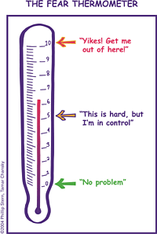](https://www.google.co.uk/url?sa=i&rct=j&q=&esrc=s&source=images&cd=&cad=rja&uact=8&ved=2ahUKEwiHu7qhhMHiAhWrAWMBHeZICDMQjRx6BAgBEAU&url=https://www.pinterest.cl/pin/19140367137763699/&psig=AOvVaw3yDe1XqdVmv2iJE5uU0tdK&ust=1559229203177787)