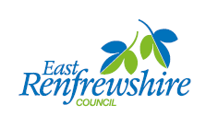
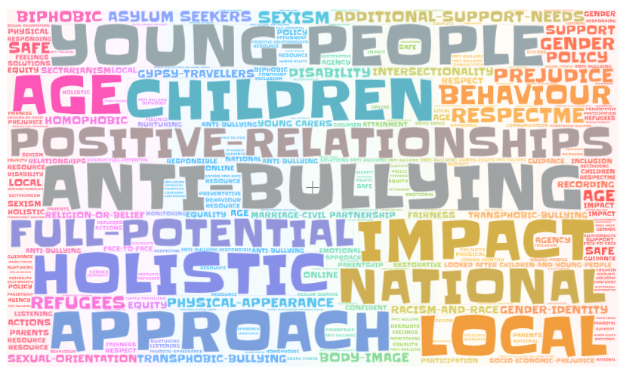

Anti – Bullying Tools for schools

Anti – Bullying resources for schools
The wide range of anti bullying resources contained within this toolkit have been organised into distinct interest groups and by levels to make them more accessible and appropriate.
Linking to Revised Standard Circular 8a Anti-Bullying (2019) this resource list provides school staff with a comprehensive set of anti bullying tools.

LOCAL AUTHORITY
Overview | Hyperlink to ER policy | Screenshot (also hyperlinked)
Respect for All  This refreshed guidance provides a framework for all anti-bullying work undertaken in Scotland. It presents clear guidance for all adults working with children and to help ensure that responses to bullying are coherent and consistent. | http://www.gov.scot/Resource/0052/00527674.pdf | 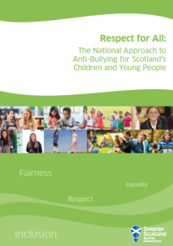
Religious/Cultural Diversity and Anti-Discrimination 2 day course delivered internally twice a year | http://intranet.erc.insider/CHttpHandler.ashx?id=10994&p=0 | 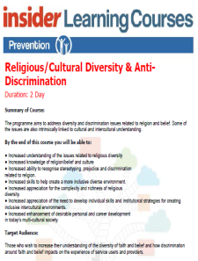
Bullying and Harassment at Work Policy | http://intranet.erc.insider/article/1061/Does-the-Council-have-a-Bullying-at-Work-policy | 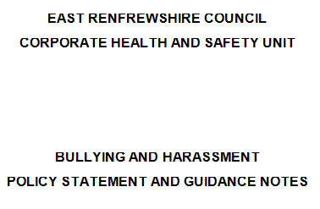
Equality Act 2010 | https://www.gov.uk/guidance/equality-act-2010-guidance | 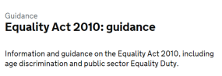
Impact Assessment EQIA | http://www.gov.scot/Topics/People/Equality/Equalities/EqualFramework/EvidencePSED/EQIA | 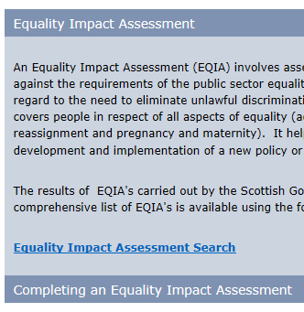

SENIOR MANAGEMENT
Policy through to Practice  If you're developing or reviewing your anti-bullying policy, our Policy through to Practice booklet takes you through the steps you need to take to ensure your policy is consultative, inclusive and appropriate for the needs of your setting. | http://respectme.org.uk/wp-content/uploads/2017/11/Policy-throught-to-Practice-2017.pdf | 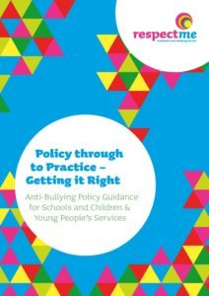
- ​This guidance is most relevant for local authority managers and primary and secondary school leadership teams. However, it also provides helpful information for early years leadership teams and for school and early years practitioners. | https://education.gov.scot/improvement/self-evaluation/Included,%20engaged%20and%20involved%20part%202:%20A%20positive%20approach%20to%20preventing%20and%20managing%20school%20exclusions%20(2017) | 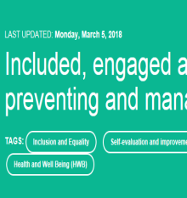
This resource provides information and guidance  to school staff on addressing homophobic,  biphobic and transphobic bullying in Scottish  schools and has been written to complement  Respect for All. | http://respectme.org.uk/wp-content/uploads/2017/11/Addressing-Inclusion-FINAL-NOV-17-1.pdf | 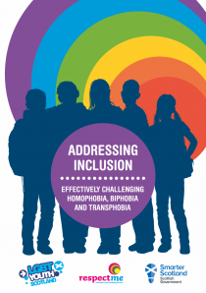
The primary aim of this piece of research  was to obtain a picture of how children  and young people are experiencing  bullying in Scotland in 2014.  Find out more. | http://respectme.org.uk/wp-content/uploads/2017/11/Bullying-in-Scotland-2014-SUMMARY-REPORT-FINAL-PDF.pdf | 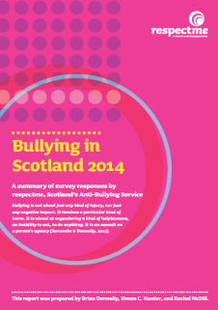
Good social media exercise.  Download the #respectmeans postcard front and reverse and join in the conversation to prevent bullying. Share what respect means to you. Adult version. | http://respectme.org.uk/wp-content/uploads/2017/11/postRM_postcard_adult.pdf  http://respectme.org.uk/wp-content/uploads/2017/11/Adult_Reverse_A4.pdf | 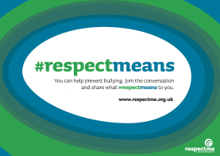
Police Scotland – What is Hate Crime? | http://www.scotland.police.uk/keep-safe/advice-for-victims-of-crime/hate-crime/what-is-hate-crime/ | 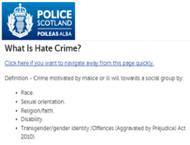
Technologies Experiences and Outcomes  Cyber resilience and internet safety – updated Nov 2016 | https://education.gov.scot/Documents/Technologies-es-os.pdf | 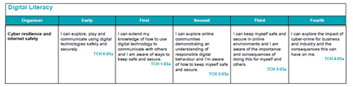
Child Rights and Wellbeing Impact Assessment CRWIA - | http://www.legislation.gov.uk/asp/2014/8/contents/enacted | 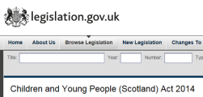

PUPIL COUNCILS
When it comes to dealing with bullying, what works for one person might not work for you, and what works for you won’t  always work for others.  Find out more. | http://respectme.org.uk/wp-content/uploads/2017/11/Bullying...-What-can-I-do-revised-leaflet.pdf | 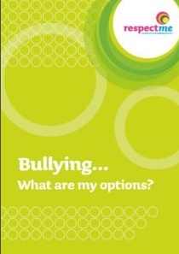
This resource has been designed for use in settings with young people e.g. classroom or youth groups. It can be used as an activity as part of anti-bullying week and at other times as part of wider learning about positive relationships and bullying behaviour.  - Groups / 10-16yrs /45mins. | http://respectme.org.uk/wp-content/uploads/2017/11/Learning_Resource-respectmeans.pdf | 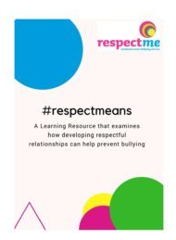
Download the #respectmeans postcard and join in the conversation to prevent bullying. Share what respect means to you. | http://respectme.org.uk/wp-content/uploads/2017/11/RM_postcard_young-person.pdf | 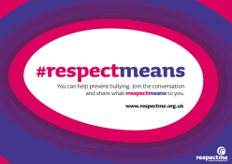
Responding to Bullying. What are my options?  A guide for young people.  - Groups / 10-16yrs /45mins. | http://respectme.org.uk/wp-content/uploads/2017/11/Learning_Resource_Responding_What_are_my_options.pdf | 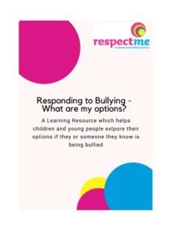

PARENTS/PARENT COUNCILS
Bullying - A guide for parents & carers  This booklet is designed for parents and carers whose child is being bullied or is involved in the bullying of others. It introduces practical strategies to respond to and understand bullying behaviour – both online and face to face. | http://respectme.org.uk/wp-content/uploads/2017/11/Bullying-a-guide-for-parents-and-carers-2016.pdf | 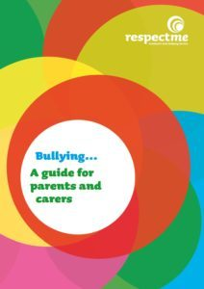
The primary aim of this piece of research was to obtain a picture of how childrenand young people are experiencing  bullying in Scotland in 2014.  Find out more. | http://respectme.org.uk/wp-content/uploads/2017/11/Bullying-in-Scotland-2014-SUMMARY-REPORT-FINAL-PDF.pdf
Online Safety Workshop  This workshop is designed to increase parents' and carers' awareness of bullying and the other risks and challenges children and young people can face online. The workshop includes a practical, hands-on session, looking at how to set and manage profiles and privacy settings on different social networking platforms, to help ensure that children and young people are safe online.  For further information, contact us: enquire@respectme.org.uk  View the Online Safety Workshop here | http://respectme.org.uk/wp-content/uploads/2017/05/Online-Safety-Workshop.pdf
Responding to Bullying - Parents' Workshop  This workshop is designed to increase parents’ and carers’ awareness of bullying behaviour and to look at the different ways they can respond if their child is being bullied, or is involved in the bullying of others. This workshop also offers guidance on how schools and parents can work together to create inclusive environments and provide effective support for children and young people. | enquire@respectme.org.uk  https://respectme.org.uk/training/programmes-and-calendar/
When it comes to dealing with bullying, what works for one person might not work for you, and what works for you won’t  always work for others.  Find out more. | http://respectme.org.uk/wp-content/uploads/2017/11/Bullying...-What-can-I-do-revised-leaflet.pdf
Responding to Bullying. What are my options?  A guide for young people.  - Groups / 10-16yrs /45mins. | http://respectme.org.uk/wp-content/uploads/2017/11/Learning_Resource_Responding_What_are_my_options.pdf
Good social media exercise.  Download the #respectmeans postcard front and reverse and join in the conversation to prevent bullying. Share what respect means to you. Adult version. | http://respectme.org.uk/wp-content/uploads/2017/11/postRM_postcard_adult.pdf  http://respectme.org.uk/wp-content/uploads/2017/11/Adult_Reverse_A4.pdf
Technologies Experiences and Outcomes  Cyber resilience and internet safety – updated Nov 2016 | https://education.gov.scot/Documents/Technologies-es-os.pdf
Thinuknow  Advice for parents regarding online safety | www.thinkuknow.co.uk/parents
Common Sense Media  Media advice for parents | https://www.commonsensemedia.org/#
NSPCC Net Aware  Social networking advice for parents from the NSPCC | http://www.net-aware.org.uk/
Internet Matters  Online safety advice for parents | http://www.internetmatters.org/ | 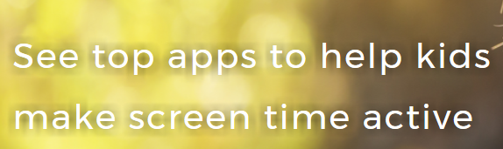
NSPCC/O2  Parental controls advice from NSPCC | https://www.nspcc.org.uk/preventing-abuse/keeping-children-safe/online-safety/parental-controls/ | 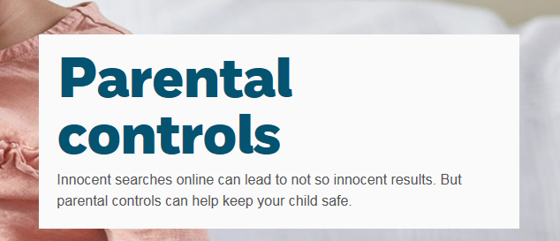

EARLY LEVEL
Feeling Happy, Feeling Safe is a series for pre-school children to watch with parents, carers or professionals. Each short film is designed to open conversations about emotions and safety, and supplies discussion questions. | https://www.kidscape.org.uk/resources/feeling-happy-feeling-safe/
 | https://www.kidscape.org.uk/media/38473/watching-fhfs-with-children.pdf |  | 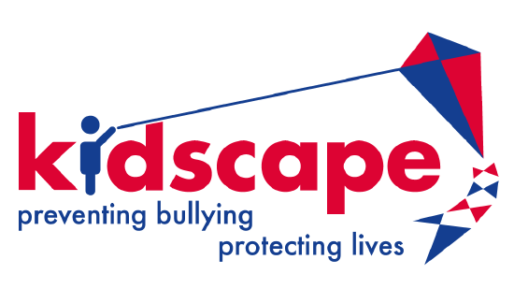
FIRST LEVEL
Good social media exercise.  Download the #respectmeans postcard front and reverse and join in the conversation to prevent bullying. Share what respect means to you. Pupil version. |  | http://respectme.org.uk/wp-content/uploads/2017/11/RM_postcard_young-person.pdf
SECOND LEVEL
This resource has been designed for use in settings with young people e.g. classroom or youth groups. It can be used as an activity as part of anti-bullying week and at other times as part of wider learning about positive relationships and bullying behaviour.  - Groups / 10-16yrs /45mins. |  | http://respectme.org.uk/wp-content/uploads/2017/11/Learning_Resource-respectmeans.pdf
Responding to Bullying. What are my options?  A guide for young people.  - Groups / 10-16yrs /45mins. |  | http://respectme.org.uk/wp-content/uploads/2017/11/Learning_Resource_Responding_What_are_my_options.pdf
Good social media exercise.  Download the #respectmeans postcard front and reverse and join in the conversation to prevent bullying. Share what respect means to you. Pupil version. |  | http://respectme.org.uk/wp-content/uploads/2017/11/RM_postcard_young-person.pdf
If It’s Not Gay, It’s Not Gay  New Zealand, 30 second media clip from RainbowYOUTH's first national ad campaign. We chose to address something small that contributes to much larger issues - homophobia, biphobia and transphobia.  Could be used to discuss the way the word ‘gay’ is used as banter |  | https://youtu.be/nYsUKPoW-Qo |  | 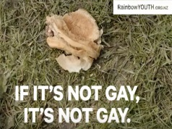
THIRD LEVEL
This resource has been designed for use in settings with young people e.g. classroom or youth groups. It can be used as an activity as part of anti-bullying week and at other times as part of wider learning about positive relationships and bullying behaviour.  - Groups / 10-16yrs /45mins. |  | http://respectme.org.uk/wp-content/uploads/2017/11/Learning_Resource-respectmeans.pdf
Good social media exercise.  Download the #respectmeans postcard front and reverse and join in the conversation to prevent bullying. Share what respect means to you. Pupil version. |  | http://respectme.org.uk/wp-content/uploads/2017/11/RM_postcard_young-person.pdf
Responding to Bullying. What are my options?  A guide for young people.  - Groups / 10-16yrs /45mins. |  | http://respectme.org.uk/wp-content/uploads/2017/11/Learning_Resource_Responding_What_are_my_options.pdf
If It’s Not Gay, It’s Not Gay  New Zealand, 30 second media clip from RainbowYOUTH's first national ad campaign. We chose to address something small that contributes to much larger issues - homophobia, biphobia and transphobia.  Could be used to discuss the way the word ‘gay’ is used as banter |  | https://youtu.be/nYsUKPoW-Qo
The S4 RSHPE Curriculum pack features lessons on Hate Crime |  | https://glowscotland.sharepoint.com/sites/EastRenfrewshireCouncil/secPSHE/Shared%20Documents/RSHPE%20Secondary%20Pack/RSHPE%20S1%20Final.pdf |  | 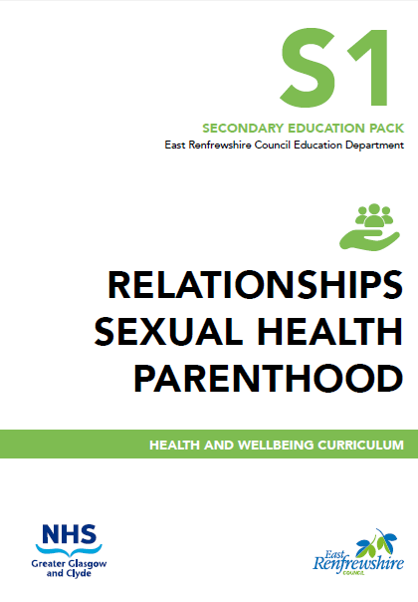
The S4 RSHPE Curriculum pack features lessons on Hate Crime |  | https://glowscotland.sharepoint.com/sites/EastRenfrewshireCouncil/secPSHE/Shared%20Documents/RSHPE%20Secondary%20Pack/RSHPE%20S1%20Final.pdf |  | 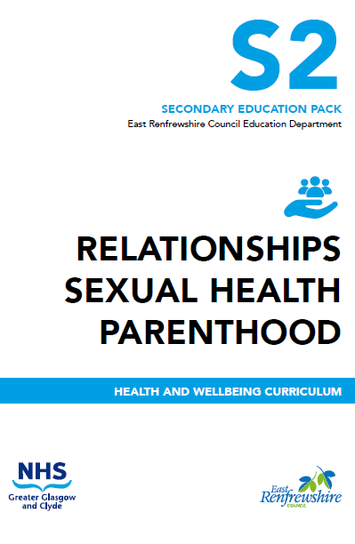
FOURTH LEVEL
This resource has been designed for use in settings with young people e.g. classroom or youth groups. It can be used as an activity as part of anti-bullying week and at other times as part of wider learning about positive relationships and bullying behaviour.  - Groups / 10-16yrs /45mins. |  | http://respectme.org.uk/wp-content/uploads/2017/11/Learning_Resource-respectmeans.pdf
Download the #respectmeans postcard and join in the conversation to prevent bullying. Share what respect means to you. |  | http://respectme.org.uk/wp-content/uploads/2017/11/RM_postcard_young-person.pdf
Responding to Bullying. What are my options?  A guide for young people.  - Groups / 10-16yrs /45mins. |  | http://respectme.org.uk/wp-content/uploads/2017/11/Learning_Resource_Responding_What_are_my_options.pdf
Homophobic language isn’t always meant to be hurtful, but how often do we use it without thinking?  Thought provoking website that can be used to facilitate discussion about homophobic language. |  | www.NoHomophobes.com |  | 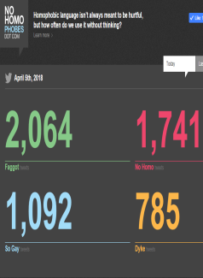
If It’s Not Gay, It’s Not Gay  New Zealand, 30 second media clip from RainbowYOUTH's first national ad campaign. We chose to address something small that contributes to much larger issues - homophobia, biphobia and transphobia.  Could be used to discuss the way the word ‘gay’ is used as banter |  | https://youtu.be/nYsUKPoW-Qo
The S4 RSHPE Curriculum pack features lessons on Hate Crime |  | https://glowscotland.sharepoint.com/sites/EastRenfrewshireCouncil/secPSHE/Shared%20Documents/RSHPE%20Secondary%20Pack/RSHPE%20S3%20Final.pdf |  | 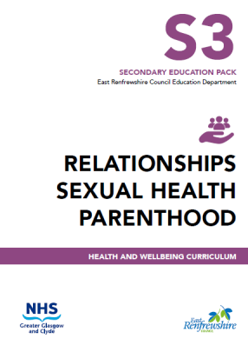
SENIOR PHASE
Good social media exercise.  Download the #respectmeans postcard front and reverse and join in the conversation to prevent bullying. Share what respect means to you. Pupil version. |  | http://respectme.org.uk/wp-content/uploads/2017/11/RM_postcard_young-person.pdf
Homophobic language isn’t always meant to be hurtful, but how often do we use it without thinking?  Thought provoking website that can be used to facilitate discussion about homophobic language. |  | www.NoHomophobes.com
If It’s Not Gay, It’s Not Gay  New Zealand, 30 second media clip from RainbowYOUTH's first national ad campaign. We chose to address something small that contributes to much larger issues - homophobia, biphobia and transphobia.  Could be used to discuss the way the word ‘gay’ is used as banter |  | https://youtu.be/nYsUKPoW-Qo |  | 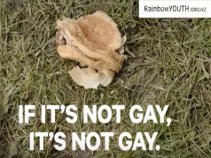
The S4 RSHPE Curriculum pack features lessons on Hate Crime |  | https://glowscotland.sharepoint.com/sites/EastRenfrewshireCouncil/secPSHE/Shared%20Documents/RSHPE%20Secondary%20Pack/RSHPE%20S3%20Final.pdf |  | 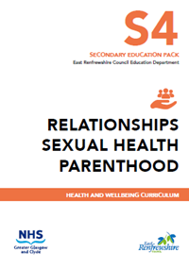

Anti-Bullying Training
Religious/Cultural Diversity and Anti-Discrimination 2 day course delivered internally twice a year | http://intranet.erc.insider/CHttpHandler.ashx?id=10994&p=0
Training is free | https://respectme.org.uk/training/programmes-and-calendar/
Bullying...it's never acceptable  This generic training provides delegates with an introduction to bullying behaviours and practical strategies which can be used to address bullying behaviour wherever it occurs. View the Bullying...it's never acceptable programme here: | https://respectme.org.uk/training/programmes-and-calendar/
Online Safety Workshop  This workshop is designed to increase parents' and carers' awareness of bullying and the other risks and challenges children and young people can face online. The workshop includes a practical, hands-on session, looking at how to set and manage profiles and privacy settings on different social networking platforms, to help ensure that children and young people are safe online.  For further information, contact us: enquire@respectme.org.uk  View the Online Safety Workshop here | http://respectme.org.uk/wp-content/uploads/2017/05/Online-Safety-Workshop.pdf
Responding to Bullying - Parents' Workshop  This workshop is designed to increase parents’ and carers’ awareness of bullying behaviour and to look at the different ways they can respond if their child is being bullied, or is involved in the bullying of others. This workshop also offers guidance on how schools and parents can work together to create inclusive environments and provide effective support for children and young people. | enquire@respectme.org.uk  https://respectme.org.uk/training/programmes-and-calendar/

What is Bullying? / Responding to Bullying
What is bullying? | http://respectme.org.uk/bullying/what-is-bullying/ | 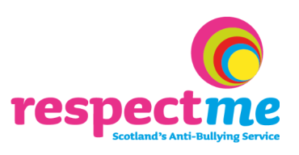
- A culture that encourages respect, values opinions, celebrates difference and promotes positive relationships will make it difficult for bullying behaviour to flourish or be tolerated | https://respectme.org.uk/anti-bullying-practice/ | 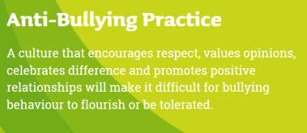
Article 12  I have the right to be listened to, and taken seriously.  One of the things the UNCRC does is to make it clear that human rights apply to children and young people, just as they do to adults. This is as true in Scotland as it is anywhere else in the world. | https://www.cypcs.org.uk/rights/uncrcarticles/article-12 | 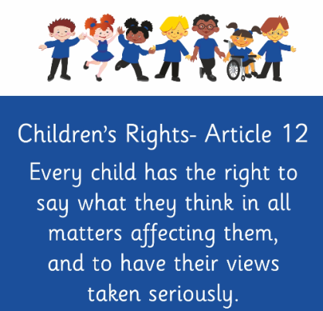
7 Golden Rules for Participation | https://www.cypcs.org.uk/ufiles/Golden-Rules-children.pdf | 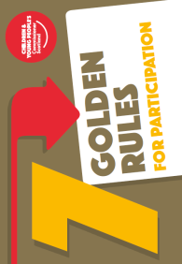
Bullying can happen anywhere, like online, at home or at school. And it can happen to anyone. But nobody has the right to hurt you or make you feel bad. If you’re experiencing bullying, we’re here to help you.  - Different kinds of bullying  - How to get help  - Banter or bullying?  - Get help if you're bullying someone | https://www.childline.org.uk/info-advice/bullying-abuse-safety/types-bullying/bullying/ | 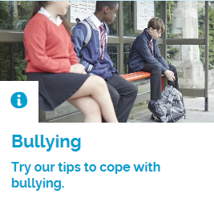

Disability Bullying

Enable Scotland (in partnership with Glasgow & Strathclyde Universities: This is an anti-bullying resource to help promote the understanding and acceptance of people with learning disabilities. The resource consists of a series of 5 lessons for S1 and S2 pupils. This is an anti-bullying resource to help promote the understanding and acceptance of people with learning disabilities. | https://talkingabout.org.uk/ | 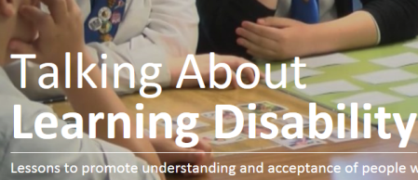
I Am Me Scotland: | http://www.iammescotland.co.uk/training-and-educational-resources/ | 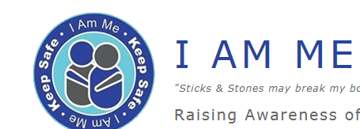
Primary school resource P5+ | http://www.iammescotland.co.uk/training-and-educational-resources/primary-school-resource/ | 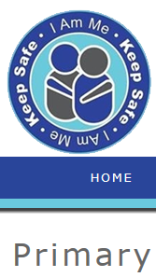
High school/adult resource | http://www.iammescotland.co.uk/training-and-educational-resources/disability-hate-crime-training-resource/ | 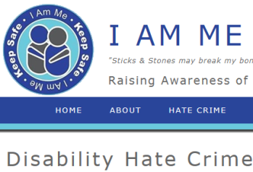
For children and young people with ASN | https://www.cypcs.org.uk/education/golden-rules/videos/golden-road | 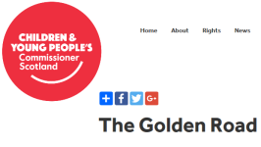

Gender Bullying
Education Scotland  STEM Gender Resources 3-19 | https://education.gov.scot/improvement/learning-resources/Improving%20gender%20balance%203-18?dm_i=LQE,5GCO5,N0RVU9,L4M5Y,1

Homophobic, biphobic and transphobic bullying
It is designed to assist both primary and secondary school staff in recognising and responding to incidents of homophobia, biphobia and transphobia in their schools.  . | https://education.gov.scot/improvement/learning-resources/Addressing%20Inclusion%20effectively:%20Challenging%20Homophobia,%20Biphobia%20and%20Transphobia | 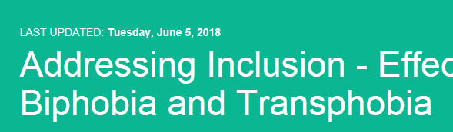

Mentors for Violence Prevention
The Mentors for Violence Prevention (MVP) programme is run in secondary schools, where learners, teaching staff, support staff, community partners and parents are all involved. | https://education.gov.scot/improvement/practice-exemplars/Mentors%20for%20Violence%20Prevention%20(MVP)%20-%20An%20overview | 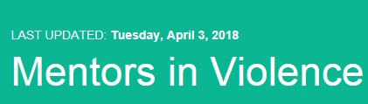

Online Safety/Bullying
Technologies Experiences and Outcomes  Cyber resilience and internet safety – updated Nov 2016 | https://education.gov.scot/Documents/Technologies-es-os.pdf
Cyberbullying is using the internet, email, online games or any digital technology to threaten, tease, upset or humiliate someone else.  - Different types of cyber bullying  - Get help with bullying videos  - What to do if you're bullying someone  - Helping a friend | https://www.childline.org.uk/info-advice/bullying-abuse-safety/types-bullying/online-bullying/ | 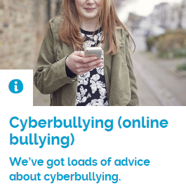
Online bullying can really knock your confidence. But you can try taking control. You can build up your confidence and feel better about yourself. Find out how.  On this page  - 7 ways to feel in control  - Go on a cyber holiday  - Tips from other young people | https://www.childline.org.uk/info-advice/bullying-abuse-safety/types-bullying/building-confidence-bullying/ | 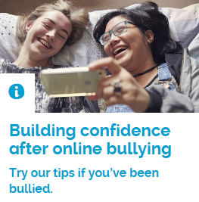
Staying safe online  When you're online it's important to stay safe and make sure you don't share things that could put you in danger. This advice will help you stay safe online.  - Keeping your device safe online  - Online communities  - Getting help with online bullying | https://www.childline.org.uk/info-advice/bullying-abuse-safety/online-mobile-safety/staying-safe-online/ | 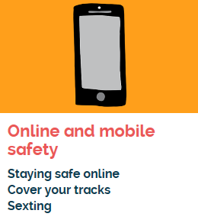

Racist Bullying

upper primary and secondary | https://education.gov.scot/improvement/learning-resources/Childline%20resource:%20Racial%20bullying%20video

Religious Bullying
​This assembly encourages appreciation of the fact that almost all religions and other moral systems of the world have come to a similar conclusion about how we should treat other people.  It can be easily altered to reflect your school community and the age of the pupils present. It would also be possible to expand on putting the 'Golden Rule' into practice, for example discussing bullying, theft or war. | https://education.gov.scot/improvement/practice-exemplars/The%20Golden%20Rule%20-%20An%20inclusion%20and%20equality%20assembly - | 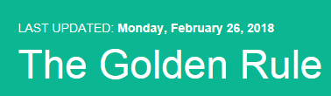

USEFUL WEBSITES
 | www.respectme.org.uk
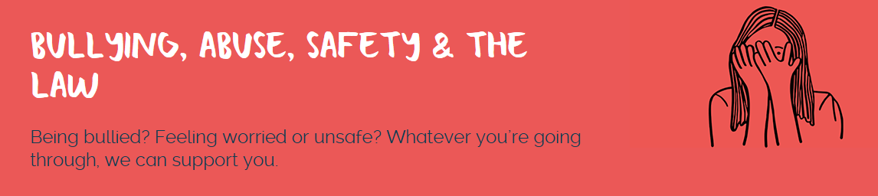 | https://www.childline.org.uk/info-advice/bullying-abuse-safety/
 | www.ceop.police.uk/
 | www.thinkuknow.co.uk/parents
 | https://www.commonsensemedia.org/#
 | http://www.net-aware.org.uk/
 | http://www.internetmatters.org/
 | https://www.nspcc.org.uk/preventing-abuse/keeping-children-safe/online-safety/parental-controls/

