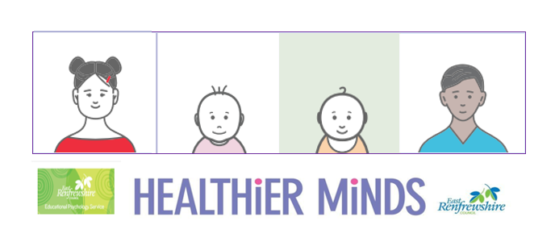

**Module 3 Session Notes**

**Activity Notes and Reflections**

**If you haven’t already done this for module 2, complete the ABC assessment or the Motivation Assessment Scale for a child you are supporting. What does your assessment tell you about the function of the behaviours and what strategies might be helpful?**

**East Renfrewshire Educational Psychology Service**

**Supporting Children with Additional Support Needs in the Early Years**

**Module 3 – Supporting Social Communication Needs**

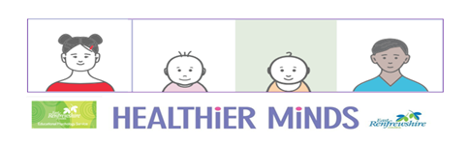

**Module 3 Case Study**

David is 3 and has just started in your room in the nursery. David comes in to the room quite happily and explores his environment. He spends most of his time between the water area or playing with trains. He is not responding to any direction from adults and is reluctant to move on from solitary repetitive play.

When David wants something he takes an adults hand and points to what he wants. You notice he can use some initial sounds as he reaches for what he wants but there are no clear words. You also notice David gives you a fleeting smile when you reach for the train he wanted.

David becomes upset when other children use toys he perceives to be his or when he can’t have what he wants. He also covers his ears when the playroom is noisy. David is not toilet trained and can become upset when he needs to be changed. When David becomes upset he cries and bangs his head and sometimes will hit or bite other children in the room. Some parents have complained that they don’t want their child to play with him.

**Read the case study provided about David and, using the information provided, consider the following questions.**

* **What are the strengths in David’s communication skills and how might you continue to build on these skills?**
* **What might some of David’s more challenging behaviours be communicating?**
* **What strategies could be helpful to promote and develop David’s skills?**