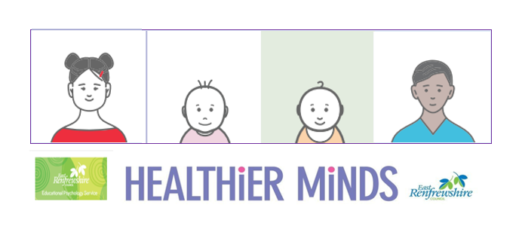

**Module 2 Session Notes**

**Complete either the SELF framework or Motivational Scale for a child you are working with. What did it tell you? How can you use the information gathered to inform the next steps for the child?**

**East Renfrewshire Educational Psychology Service**

**Supporting Children with Additional Support Needs in the Early Years**

**Module 2 – Understanding Social Communication Needs**

**Theme 2 – Assessment**

