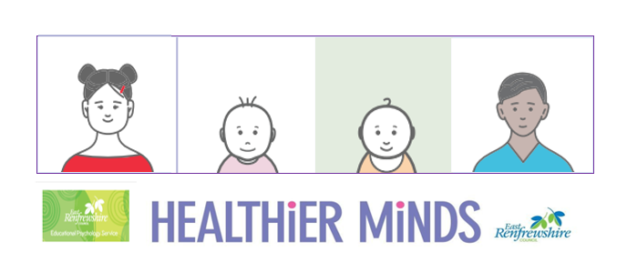

**Module 2 Session Notes**

**Activity Notes and Reflections**

**Think of a child who you support that you suspect may have difficulties in the area of social communication. What do you observe that suggests the child needs additional support to develop their social communication? Note your observations under the following headings:**

**Expressive language skills**

**Receptive language skills**

**Interactions with others**

**Behaviour**

**East Renfrewshire Educational Psychology Service**

**Supporting Children with Additional Support Needs in the Early Years**

**Module 2 – Understanding Social Communication Needs**

**Theme 1 – Understanding and Identification**



**Think of a child you know who you do not consider to have social communication needs. What stage of development would you say that child is at with regards to play (solitary, spectator, parallel, associative, cooperative)? What have you observed in the child’s play that helped your decision?**

**Still thinking about play, for each stage what might you notice that would indicate that a child requires support to develop their social communication skills? Take a moment to bullet point some possible observations for each stage.**