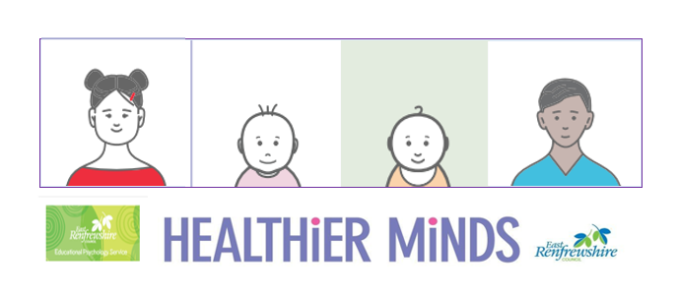

**Module 1 Session Notes**

**Activity Notes and Reflections**

**Why do you think visuals would be a useful support in your setting?**

**Complete an audit of your environment symbols – how many areas, activities, resources and routines are symbolised?**

**Pick an area that is currently unsymbolised and create some symbols using boardmaker or photographs**

**East Renfrewshire Educational Psychology Service**

**Supporting Children with Additional Support Needs in the Early Years**

**Module 1 – Universal approaches to promoting learning and wellbeing in the early years**

**Theme 1 – The Physical Environment**

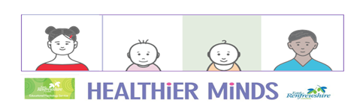

**Complete an audit of your environment symbols – how many areas, activities, resources and routines are symbolised?**

**Pick an area that is currently unsymbolised and create some symbols using boardmaker or photographs. Briefly describe the area you chose and why and reflect on the experience of symbolising. How will you encourage children and staff to make use of the symbols?**