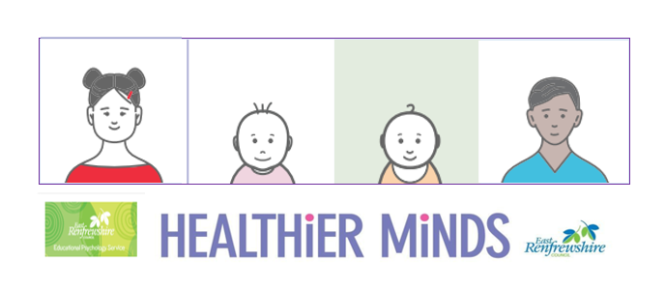

**Module 1 Session Notes**

**Activity Notes and Reflections**

**How well do you know the stages of speech and language development? Use this document to revise and consolidate your understanding:**

[**https://www.hct.nhs.uk/media/2197/stages-of-speech-and-language-development.pdf**](https://www.hct.nhs.uk/media/2197/stages-of-speech-and-language-development.pdf)

**Complete an audit of your environment symbols – how many areas, activities, resources and routines are symbolised?**

**Pick an area that is currently unsymbolised and create some symbols using boardmaker or photographs**

**East Renfrewshire Educational Psychology Service**

**Supporting Children with Additional Support Needs in the Early Years**

**Module 1 – Universal approaches to promoting learning and wellbeing in the early years**

**Theme 2 – Communication**

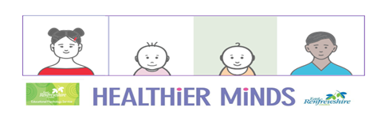

**Think of a child you support and use this document to consider where they are in their stage of development.**

**What could you do to support, promote and develop their language development further?**