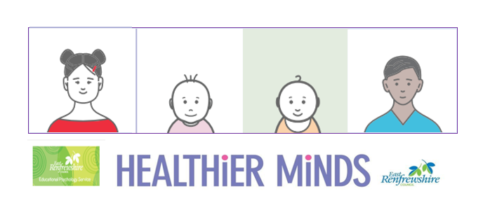

**Module 1 Session Notes**

**Complete an audit of your environment symbols – how many areas, activities, resources and routines are symbolised?**

**Pick an area that is currently unsymbolised and create some symbols using boardmaker or photographs**

**East Renfrewshire Educational Psychology Service**

**Supporting Children with Additional Support Needs in the Early Years**

**Module 1 – Universal approaches to promoting learning and wellbeing in the early years**

**Theme 3 – Interactions**

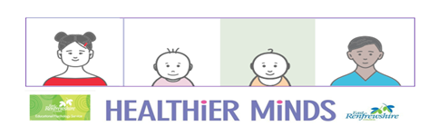

**Activity Notes and Reflections**



