Promoting Emotional Regulation in the Early Years

This guidance focuses on 2 elements of emotional regulation in young children which are fundamental to children’s social and emotional development. They are helpful precursors to developing more prosocial behaviours and problem solving skills.

- Emotional-awareness - The ability to identify one’s own and others’ emotions and thoughts, and how they influence behaviours.

- Self-regulation - The ability to successfully regulate one’s emotions, thoughts and behaviours. This includes emotional regulation and impulse control skills.

These skills are most effectively learnt in a nurturing environment through ‘co-regulation’ which comprises of 3 main elements:

A warm, positive, responsive relationship with adults where children feel respected, comforted and supported in times of stress, and confident that they will be cared for no matter what. This promotes self-efficacy and allows children to feel secure enough to practice new skills, to make and learn from mistakes

Structure the environment to make self-regulation manageable by ensuring consistency and predictability. Routines and clear expectations promote a sense of security by providing clear goals.

Teach, model and coach self-regulation skills as one would with other areas of the curriculum. Children learn by watching, following and copying others. Talk about your own feelings and how you managed, give children the language of how they might be feeling “I think you might be angry because I’ve asked you to stop this game.” Communicate that all feelings are ok to have.

Activities which aim to develop young children’s emotional awareness should be short and frequent throughout the day as young children require a lot of practice to develop and reinforce these skills. They should gradually become an embedded element of the school day rather than a discrete activity. Self regulation ‘check-ins’ are particularly useful at transition times for example a 1 minute breathing activity between an activity and tidying up or an energiser after breaktime.

Using Play and Stories to Develop Emotional Awareness

- Use any story book to discuss the characters’ emotions and use this as a starter for discussing the childrens’ emotions
  - Draw faces onto small balls or plastic eggs to reinforce emotions as you read the story or ask children to choose the matching egg

- These books are great for exploring emotions with children, helping them to identify and name emotions and find ways to manage big feelings
- How are you Feeling Today? By Molly Potter
- The Colour Monster by Anna Llenas
- The Worrysauras by Rachel Bright
- Sully the Seahorse by Natalie Pritchard
- Monty the Manatee by Natalie Pritchard
- Listening to my Body by Gabi Garcia
- In My Heart by Jo Witek
- Feelings: Inside my Heart and in my Head by Libby Walden
- Ruby’s Worry: A Big Bright Feelings Book by Tom Percival
- Ravi’s Roar by Tom Percival
- Today I’m a Monster by Agnes Green
- Find your Calm by Gabi Garcia
- Happy: A Children’s Book of Mindfulness by Nicola Edwards
- Breathe like a Bear by Kira Willey

- Use puppets or cuddly toys to act out emotions and scenarios

- Inside Out clips are great for starting discussions about feelings

- Use play opportunities to model and coach emotional awareness (“I think you are feeling…. because) and problem solving skills (“how could we sort this out?”) as the child will be most relaxed, engaged and motivated during self directed play

Activities to Encourage Emotional Awareness

Make facial expressions on wipe clean face outlines using playdough or white board pens
Use paper plates or circles and encourage children to cut out the shapes of facial features to create different facial expressions
Match pictures of facial expressions to the emotion word/visual
Group pictures of facial expressions/body language together
Create a collage using the Inside Out pictures and other feelings pictures
Use a large colour chart to pick what colour you feel like and why
Use a large animal chart to pick what animal you feel like and why
Large facial expressions/Inside Out characters chart to pick how you feel and why
Have a mirror in the room and use a glass pen to draw the children’s reflections with different facial expressions.
Match the event to the emotion visual (e.g. birthday party, spiders, going to the park, friend going home after a playdate, someone taking a toy)
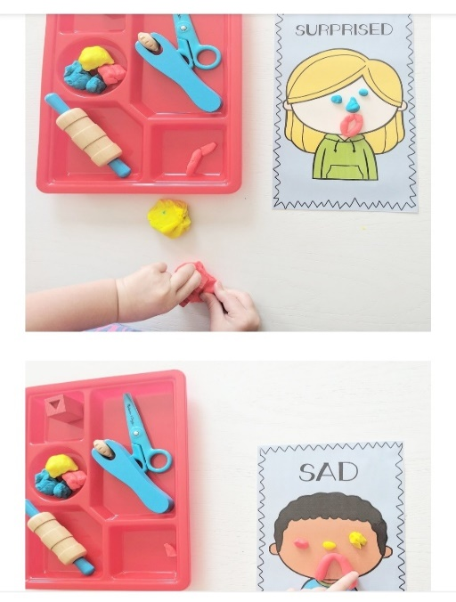
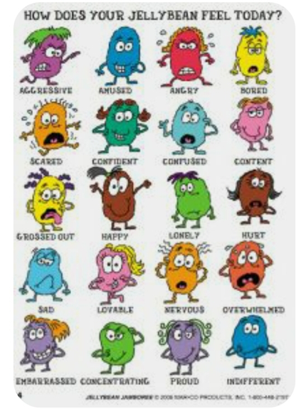

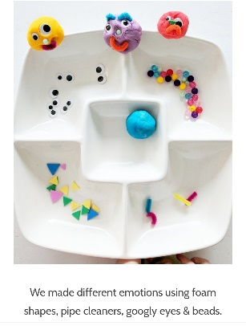
Self Regulation
These are a combination of breathing, relaxation, mindfulness and energising techniques.
Breathing Techniques
Sniffing Hot Chocolate
Together pretend to hold a cup of hot chocolate up to your lips. Encourage the child to 1st smell the cocoa by breathing deeply through her nose and exhaling through her mouth to cool it down. Encourage this pattern a few times experimenting with the breath so it’s not too hard or fast (and blows the cocoa out of the cup) but not too slow either.
Dandelion Breathing
Smell the dandelion then blow the seeds away. Encourage the child to blow away more seeds by blowing for longer.
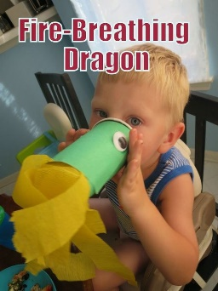
Fire Breathing Dragon
Make a dragon out of a cup and strips of tissue paper. Practice making the dragon breathe fire. Demonstrate that the longer your out breath, the longer the ‘fire’ lasts.

Balloon Breathing
Lying or sitting down ask the child to place his hands on his tummy. Imagine a round balloon is in there and we need to blow it up by breathing in – watch your tummy rise and let the air out of the balloon by breathing out – watch your tummy sink. Once they’ve practiced this encourage them to count their breaths in and their breaths out.
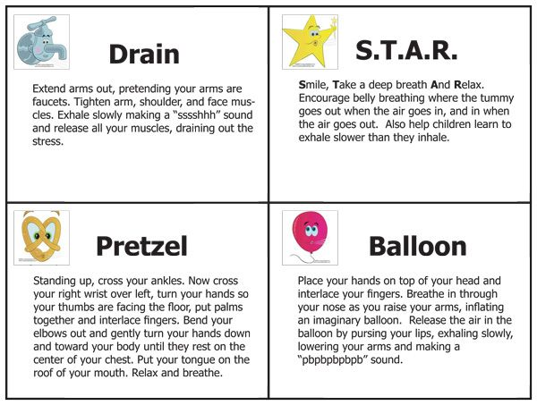

Relaxation Techniques and Poems

Little Mouse
- Release the hands and gently fold over the legs with the forehead resting on the ground.
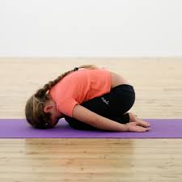
- Be quiet and still like a little sleeping Dormouse.

Do Nothing Doll

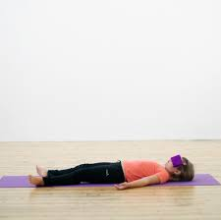
Roll onto the back and lie flat.
- Make sure the spine is straight and look up at the ceiling.
- Close the eyes.
- Let the arms and legs flop onto the mat like a rag doll.
- Feel the ground beneath you.
- Imagine the mat/the floor is a piece of hot toast and you are a little ball of butter gently melting over the toast.
Relax and Release
Pull the hands into very tight fists.
Ahh, let them go with a swish, swish, swish.
Squeeze tight, tight, tight with all the might.
Now just relax and make them light.
Curl the toes into a ball.
Now let them go, release them all.
Squeeze tight, tight, tight with all the might.
Now just relax and make them light.

Guided relaxation as a cat! http://www.moodcafe.co.uk/media/26930/Relaxleaflet.pdf
Big Fat Puddle
Pretend you are standing in your bare feet in a big, fat muddy puddle
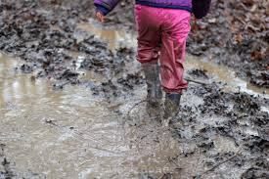
Squish your toes right down in the mud
Try to get right down to the bottom of the puddle
Now step out of the mud and relax your feet
Let your toes go loos and see how nice that feels
Back into the muddy puddle
Squish your toes right down
Use your legs to help you push right down
Push down, harder, harder
Come back out the puddle now
Relax your feet, legs and toes
It feels so good to relax – feel all warm and tingly all over

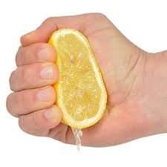
Squeezing Lemons
Imagine squeezing all the juice out of a lemon by closing your fist tight. Hold for 5 seconds then release for 5. Imagine you can see the lemon juice dripping.
Repeat with the same hand 5 times and then swap to the other hand
Focus on how each hand feels when it’s squeezing the lemon and relaxing and compare to the other hand

Fly on your Nose

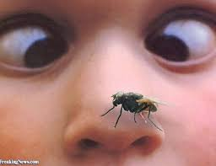
Now a nasty old fly has landed on your nose. Try to get him off without using your hands. Wrinkle up your nose. Make as many wrinkles in your nose as you can.
Good, you’ve chased him away. Now you can relax your nose.
OOPS, here he comes again, right in the middle of your nose. Shoo him off. Wrinkle your nose again very tightly. Notice how your cheeks, your mouth, your eyes and your forehead get all wrinkled too. Make lots of tight wrinkles to scare him off.
Hold it tight. Okay, now you can let go. He’s gone for good now. You can relax. Let your face go smooth. No wrinkles anywhere.

Sensory Breaks

Experiment with different sensory activities and then create a chart with photos of each activity (photos of the activity are better than stock photos or cartoons) – allow children to choose which activity they want for their sensory break e.g.

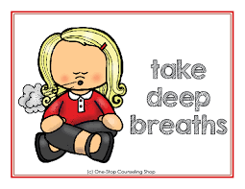
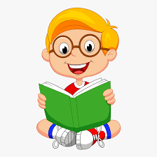
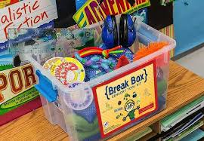
Deep breaths
Blow bubbles
Squeeze Toy
Read a Book
Take a Break Box
Blanket
Listen to music
Hand massage

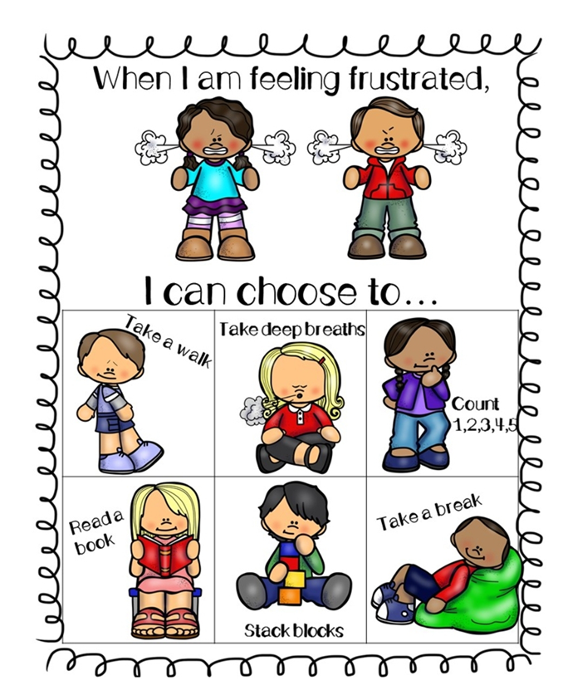

Sensory Stories can be as simple or elaborate as you want but they are great for building in sensory experiences to a story e.g https://inclusiveteach.com/2019/07/13/blue-abyss-sensory-story/

Mindfulness Approaches – these techniques aim to focus the child on the present moment and their surroundings.
Safari
Say that you will be going on a safari, and their goal is to notice as many birds, bugs, creepy-crawlies, and any other animals as they can. Anything that walks, crawls, swims, or flies is of interest, and they’ll need to focus all of their senses to find them, especially the little ones.
Texture bag
Place several small, interestingly shaped or textured objects in a bag, and have each child reach in to touch an object, one at a time, and describe what they are touching. Make sure they don’t take the object out of the bag, forcing them to use only their sense of touch to explore the object.
I Spy
It’s the game you know and love but instead of sounds the child has to find objects which fit into a specific category.
e.g, ‘I spy with my little eye something….
- Squishy
- Pink
- Round
- Funny
Encourage the child to take a turn of asking you to find something

Walk a Maze
Take some chalk outside and create a pattern on the ground like a snake or a maze or a curvy line and ask the child to try to follow it like on a tight rope and be careful not to fall off. Watch out for the scary crocodiles or lava below!!

Energising Brain Breaks
See the next few pages for visual prompts for self-regulation breaks.

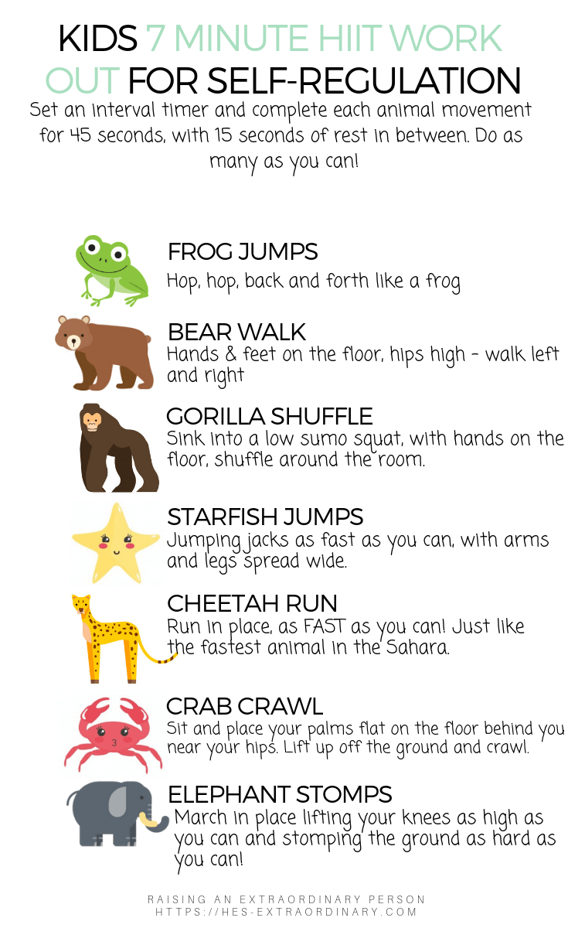

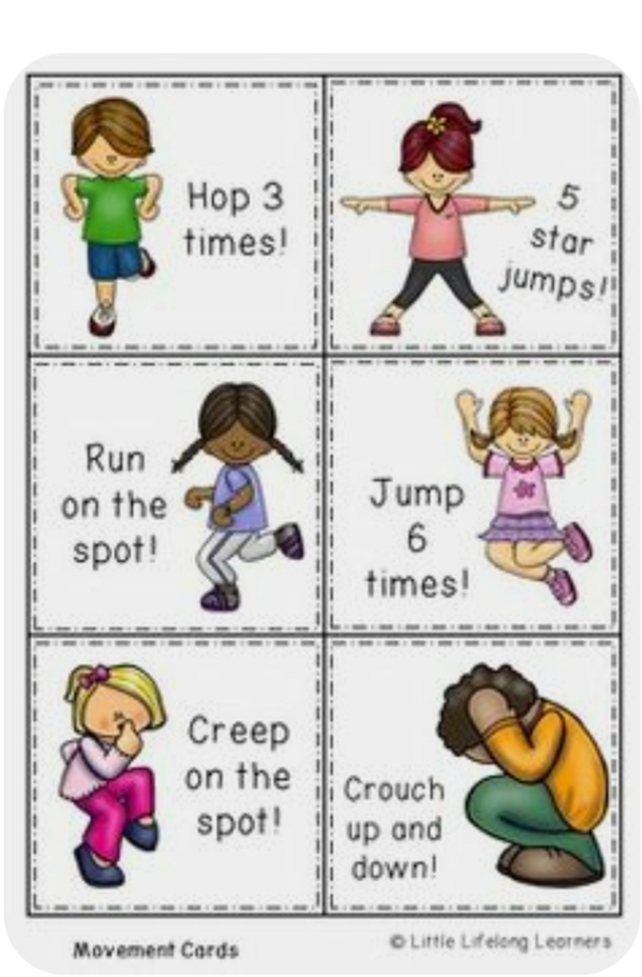

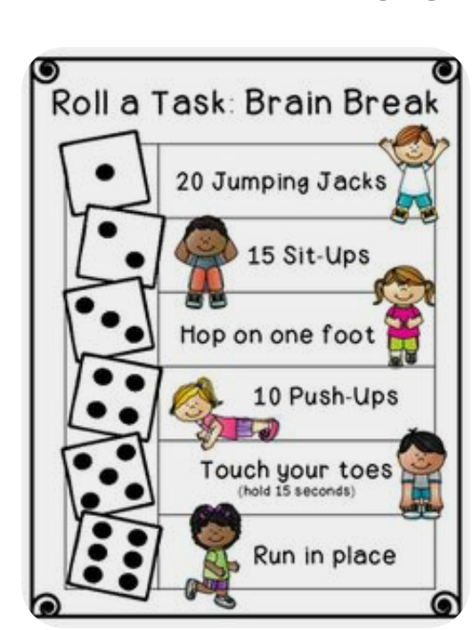

Linking to the Curriculum for Excellence

- I am aware of and able to express my feelings and am developing the ability to talk about them.
- I know that we all experience a variety of thoughts and emotions that affect how we feel and behave and I am learning ways of managing them.
- I understand that there are people I can talk to and that there are a number of ways in which I can gain access to practical and emotional support to help me and others in a range of circumstances.
- I understand that my feelings and reactions can change depending upon what is happening within and around me. This helps me to understand my own behaviour and the way others behave.
- I know that friendship, caring, sharing, fairness, equality and love are important in building positive relationships.
- As I develop and value relationships, I care and show respect for myself and others.
- I understand the importance of mental wellbeing and that this can be fostered and strengthened through personal coping skills and positive relationships.
- I am learning skills and strategies which will support me in challenging times, particularly in relation to change and loss.

