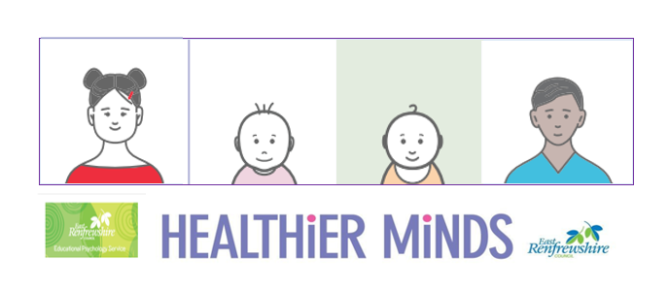

**Module 2 Session Notes**

**Can you make these targets more SMART?**

**I can play with my friends**

**I am learning to talk**

**Jamie will enjoy nursery**

**Louise will not bite her friends**

**Develop 3 appropriate SMART targets for a child you work with**

**East Renfrewshire Educational Psychology Service**

**Supporting Children with Additional Support Needs in the Early Years**

**Module 2 – Understanding Social Communication Needs**

**Theme 3 – Planning**

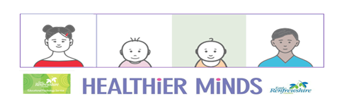

**Develop 3 appropriate SMART targets for a child you work with**