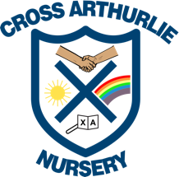

Moving to Cross Arthurlie Nursery

I am going to be moving to a new nursery.

My new nursery is going to be Cross Arthurlie Nursery.

I will say goodbye to some of the boys and girls and the teachers, who are staying at Arthurlie Family Centre.

I will be going to Cross Arthurlie Nursery with my group and my teacher.

I will meet new friends and new teachers at Cross Arthurlie Nursery.

Things will look different at my new nursery but that is ok. I can ask my teacher for help if I am unsure of anything.

My new nursery has one big playroom inside and one playground outside for me to choose from.

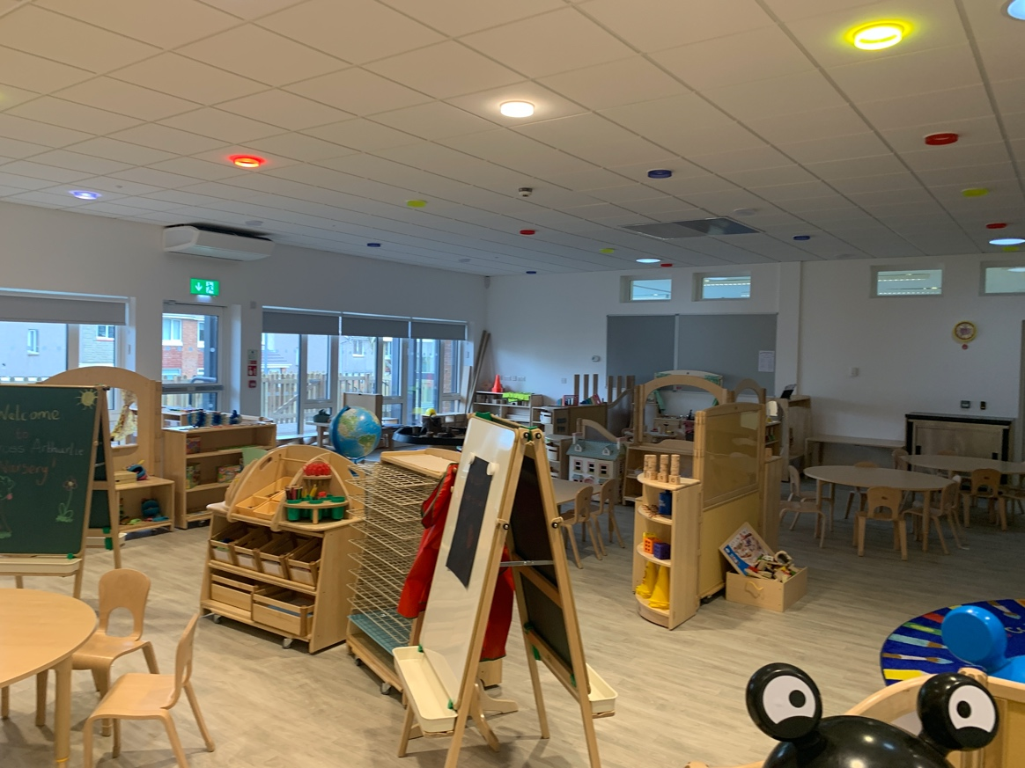

It is going to be really fun going to a new nursery and Cross Arthurlie nursery has lots of toys for me to play with.

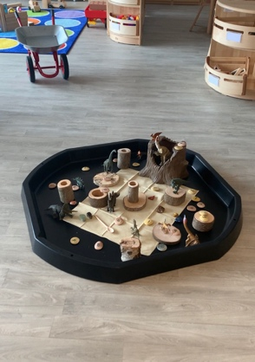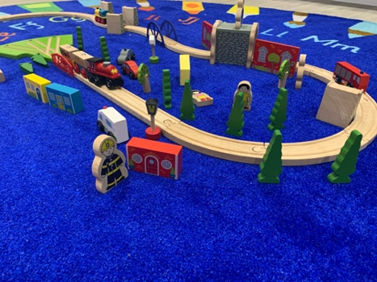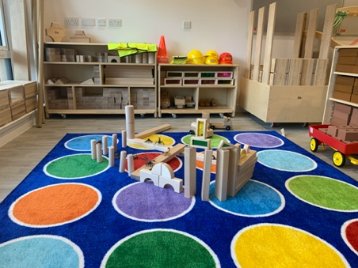

My teachers and the other children are really excited to meet me.

