Curricular area | Spelling |  | Reading | Handwriting
Literacy | Today we are going to practise spelling our tricky words.  come  some  said  here  they  Use your jotters or the google doc to spell your tricky words. Remember to write each word 3 times.  Choose how you write your words: rainbow writing, bubble writing, curly writing, capital letters.  Challenge:  choose one of your tricky words and use it in a sentence.  https://www.youtube.com/watch?v=3NOzgR1ANc4 |  | As I can't give out real books on a Tuesday as normal I have found this great website.  Each week I will set each reading group at least 1 new book.  Remember to read this book everyday.  I will also add books to listen to and songs on this site to enjoy together. There are book to support our recent topic of space so I will add these to your library to read at your own pace.  Class Log In Instructions:  Open up web browser  Go to www.getepic.com/students  Log in with your class code – on google classroom  You can use this website from 9am to 3pm.  Select your name and you are in! | Choose a page in your handwriting booklet that is in your folder to complete. Can you make a pattern using different colours?  Remember its important to practise the letters on the lines at the bottom yourself. Make it as neat as you can.  Also have a go at this fun formation game.  https://www.abcya.com/games/letter_trace
Numeracy | Shape:  Today we are going to have a go at using shapes to make an animal or person. You can use the google drawings link to make your own online or have a go in your jotter. If you can upload a picture of your animal add it to the comments.  If you need some help to draw the shapes see if you can find something in the house to draw around.  What shapes did you use to make your animal?  What animal did you draw?  https://docs.google.com/drawings/d/16LRT6WuG83GkhhlDeJIiDOVzes3NwnY_bPX-jY3xwi8/edit?usp=sharing  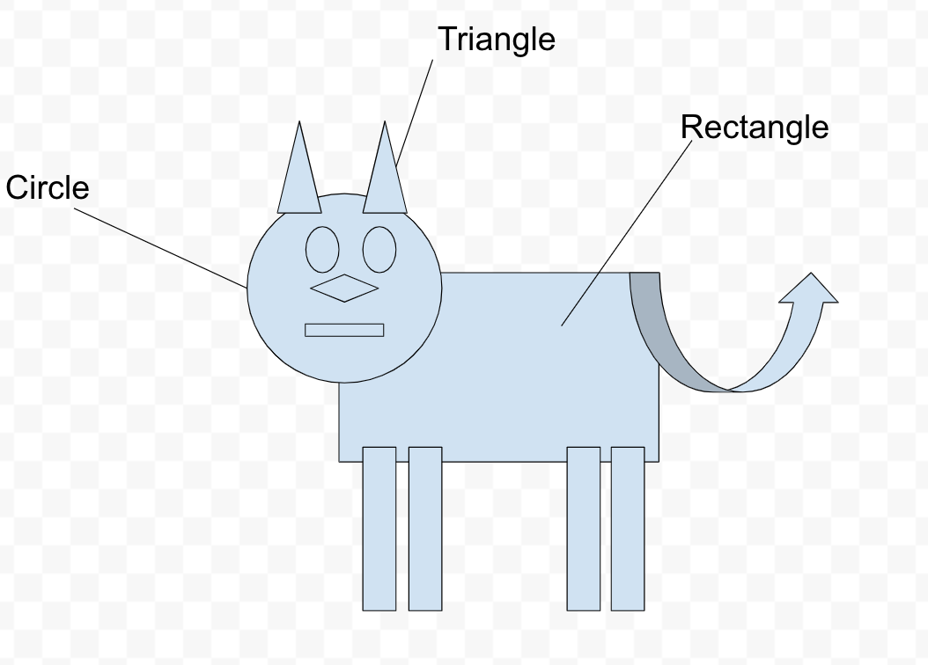 | Shape and pattern game.  https://www.topmarks.co.uk/ordering-and-sequencing/shape-patterns  Go on a shape hunt around your house, what 2D shapes did you find?  Remember that a 2D shape is a flat shape and one you can’t pick up and hold.
Other | Health and Wellbeing  Lets get active with Joe Wicks  On a Tuesday we normally have PE so today we are going to get moving and keep our fitness up at home.  Use the link to get your bodies moving with Jo. you can find it on you tube also. It starts at 9am and is on every day so you can do it all week if you want to.  https://www.thebodycoach.com/blog/pe-with-joe-1254.html  Have fun!

