Adverbs
Read the adverbs, then read the story. Write an adverb in each space.

loudly | suddenly | carefully
quickly | secretly | proudly
quietly | happily | slowly
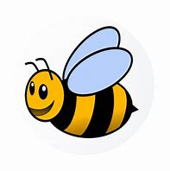
Bee’s Busy Day

Bee woke up ______________________ and flew ___________________ down the hive to have breakfast. She buzzed ______________________ as she flew to the farm. She _____________________ collected as much pollen as she could and flew ___________________ back to the hive.
She smiled _________________________ to herself. Bee and her friends, Inky and Snake, had planned a day out.

