My
Carbon
Footprint
Instructions

- Either use this template or draw around your own foot.

- Divide the footprint up to show how much you use for each of the totals for school, home and holiday.

- Divide each section further to show how you use energy, e.g. showers, watching TV, different sorts of holidays...

- Use colour, pictures and text to decorate your footprint.

Question to answer:
- How could you reduce your carbon footprint? E.g. sharing lifts, taking holidays without using a plane, less TV...
- Write your answers around the footprint.
Calculating your Carbon Footprint
Use these values to calculate your overall Carbon Footprint.
SCHOOL
- How far do you travel to school? (one way only)
- How do you get to school?
  - Walk = 0
  - Bicycle = 0
  - Bus = 103 kgs CO₂ per mile
  - Train = 91 kgs CO₂ per mile
  - Car
    - How many travel with you?
      - 0 = 324 kgs CO₂ per mile
      - 1 = 162 kgs CO₂ per mile
      - 2 = 108 kgs CO₂ per mile
      - 3 = 81 kgs CO₂ per mile

HOME

- TV watch 1hr = 46 kgs CO₂ per hour
- Computer 1hr = 27 kgs CO₂ per hour
- Lights 1hr = 20 kgs CO₂ per hour
- Bath = 71 kgs CO₂ each
- Shower = 42 kgs CO₂ each

HOLIDAYS

- Holidays
  - UK car = 138 kgs CO₂ per holiday
  - UK train = 39 kgs CO₂ per holiday
  - UK bus = 44 kgs CO₂ per holiday
  - UK plane = 290 kgs CO₂ per holiday

  - Europe car = 344 kgs CO₂ per holiday
  - Europe train = 96 kgs CO₂ per holiday
  - Europe bus = 110 kgs CO₂ per holiday
  - Europe plane = 870 kgs CO₂ per holiday

  - Outside EU car = 688 kgs CO₂ per holiday
  - Outside EU train = 193 kgs CO₂ per holiday
  - Outside EU bus = 220 kgs CO₂ per holiday
  - Outside EU plane = 2900 kgs CO₂ per holiday

Working out my Carbon Footprint

School
- Colour in how you get to school.
- Do this calculation and fill in the last box:

How many miles X number I coloured = CO₂ I use

How many miles to get to school | Transport I use | CAR ONLY: how many pupils come with me | Miles x number I’ve coloured in
_____ miles | Car -------------- | 0 = 324 | kgs CO₂
 | Bus = 103 | 1 = 162
 | Bicycle = 0 | 2 = 108
 | Walk = 0 | 3 + = 81

Home

How much I use: |  |  | How much CO₂ |  | Total CO₂
TV | hours per night | X | 46 | =
Computer | hours per night | X | 27 | =
Lights | hours per night | X | 20 | =
Bath | each week | X | 71 | =
Shower | each week | X | 42 | =
Add up all the totals to make the overall total: |  |  |  |  | kgs CO₂

Holidays
- Colour in the holidays you have each year.
Add up all the numbers!
138 + 39 + 870 =
1047 kgs CO₂

e.g. You might have 3 holidays a year:
  - One in the UK by car = 138
  - One in the UK by train = 39
  - One in Europe by plane = 870

How I get there: | Colour in all of the different types of holiday you have each year:
 | UK | Europe | Outside Europe
Car | 138 | 344 | 688
Bus | 44 | 110 | 220
Train | 39 | 96 | 193
Plane | 290 | 870 | 2900
Add up all of the numbers = _________________ kgs CO₂

TOTALS

School: kg CO₂ per year

Home: kg CO₂ per year

Holidays: kg CO₂ per year

OVERALL TOTAL: kg CO₂ per year

Na
Plane

Did you know?
The average grown up has a carbon footprint of 14000kg a year. By 2050 we need to cut that down to 2000 kg a year!

Calculating my Carbon Footprint
How far do you travel to school? (one way only)
miles
Europe

Bicycle

Hours of TV each night:

Hours of computer each night:

Hours my light is on each night:

Number of baths per week:

Number of showers per week:
HOME
HOLIDAY
How many holidays do you have each year?

UK

I go on holiday to:
Outside Europe

I travel on holiday by:
Car

Bus
Train

3+

2

1

0

I share a lift in the car with this many other pupils:
I travel to school by:
Car

Walk

Bus
SCHOOL
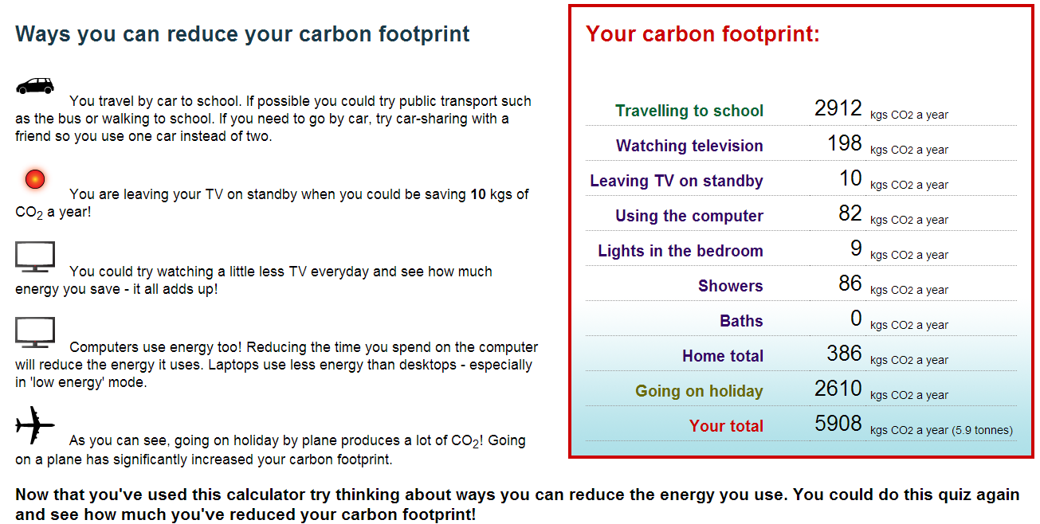
Example Carbon Footprint

