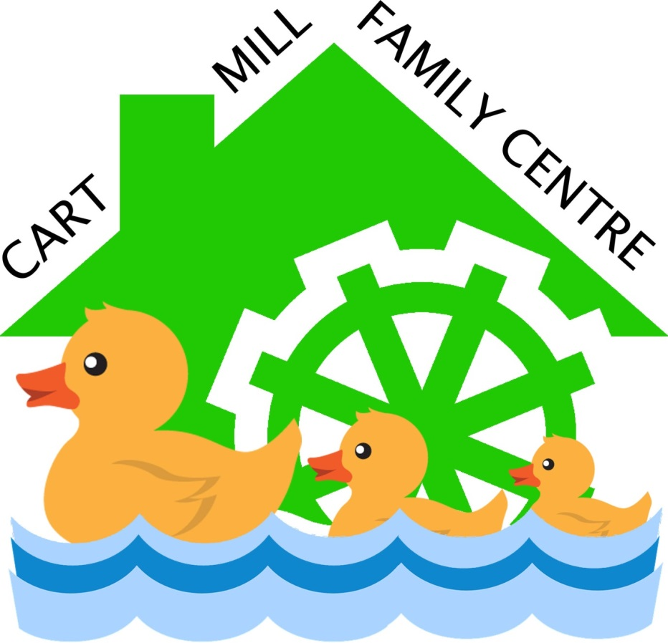

Cart Mill Family Centre aims to be the best place for children to learn and develop

Information
for
Parents & Carers
2025-2026

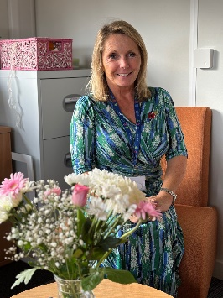
Welcome To Our Centre

“We aim to be the best place for children to learn and develop”
We are proud to put children at the heart of all we do within our centre. We respect children and their right to be a child. The wellbeing, learning and development of each individual child is carefully supported, nurtured and challenged in our learning spaces indoors and outdoors.
We value working in partnership with parents and carers to ensure that children are given the best possible learning experiences that match their interests and stage of development. Our highly trained educators provide an exciting play-based curriculum that supports children’s curiosity, inquiry and creativity.
We have a website that we constantly update and our learning blog is updated daily to show you a snapshot of the learning that takes place every day. You can check this out at
https://blogs.glowscotland.org.uk/er/cartmill/
We appreciate that selecting an early learning and childcare setting can be a difficult task and are delighted that you have chosen to send your child to Cart Mill.

Kindest regards
Angela Kerr
Angela Kerr
Head Teacher
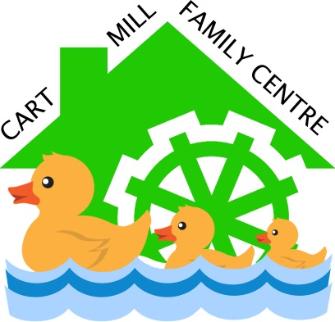
Our Vision

Cart Mill Family Centre aims to be the best place for children to learn and develop.

We provide an exciting curriculum which puts the child at the centre of learning. We will through striving for excellence in all that we do enable children to become, successful learners, confident individuals, responsible citizens and effective contributors.

Our Aims

We seek to: -
- Provide safe, secure, healthy and stimulating learning environments.

- Promote each child’s self-esteem and encourage positive attitudes towards themselves and others.

- Ensure each child receives an appropriately child centred, broad and balanced curriculum.

- Foster genuine partnership with parents and carers.

- Enable each child to reach their full potential by carefully listening and responding to them.

- Implement effectively national and local policies.

- Ensure all resources are easily available to children and are natural whenever possible.

- Use the outdoor spaces to extend and enrich children's learning.

- Work in partnership with the wider community.

- Celebrate all forms of achievement.

- Ensure our Family Centre provides an ethos of trust, where childhood is viewed as a free, innocent, special time of life, where children are encouraged to be inquisitive, have fun and explore.

Cart Mill Family Centre opened in November 2016 and offers high quality learning and play opportunities for 110 full time children aged 2-5 year. Our bright open-plan playrooms have direct access to the outdoor learning spaces which our children access all day, every day.
Our Ethos
Children come first in Cart Mill Family Centre. We respect children and their right to be a child and we believe that children:
- Are rich, competent and resourceful
- Are curious, inquiring and creative
- Are creators of knowledge drawn from their own experiences
- Have the right to be consulted, listened to and heard
- Have the right to interact and communicate with one another and with caring respectful adults.

Curriculum for Excellence
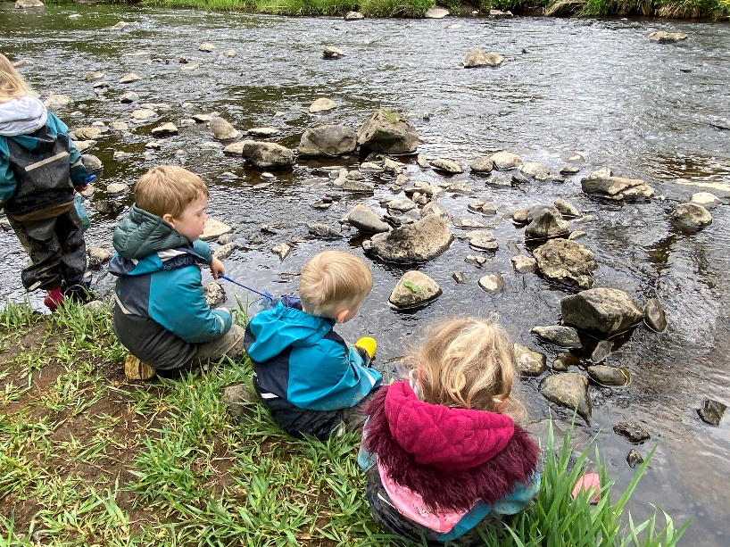
At Cart Mill Family Centre we provide an exciting curriculum which puts the child at the centre of learning. We will through striving for excellence in all that we do enable children to become, successful learners, confident individuals, responsible citizens and effective contributors. We provide early level learning experiences across all 8 areas of the curriculum. We particularly value listening to children, learning in the outdoors and learning through play. We work in partnership with parents and families and we use our local community and beyond to extend and enrich the learning experiences of our children.

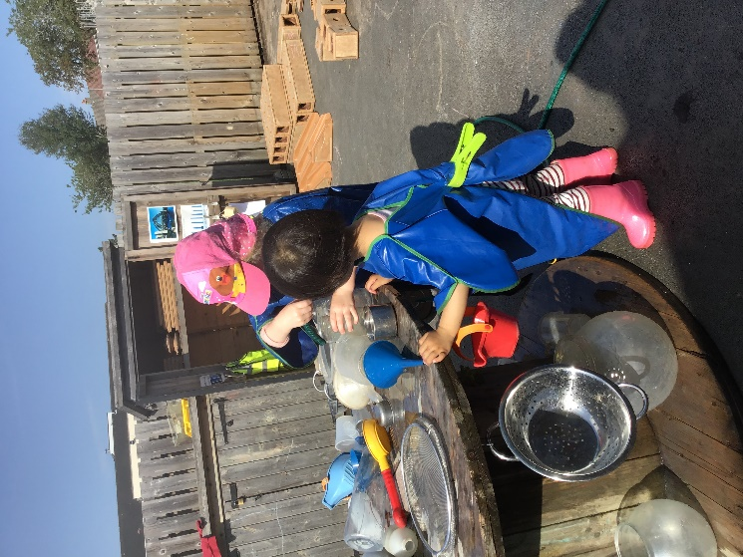
Outdoor Learning
Learning in the outdoors at our centre is just as valuable as learning indoors. We want the children to experience the changing seasons, the weather, wildlife, planting and growing as well as just being able to explore and play. We believe that there is no such thing as bad weather only bad clothing. We will use the outdoors every day and in all weathers so please ensure that you provide suitable waterproof and warm clothing, cosy socks and a pair of Wellington boots. We have a “Welly Shed” so if you can leave a pair here for your child that would be great. Please label your child’s clothing so that if things get lost we can identify them easily. We also require you to provide at least two complete sets of clothes for your child which should be hung up at their peg in a bag that does not have drawstrings please.
Forest School
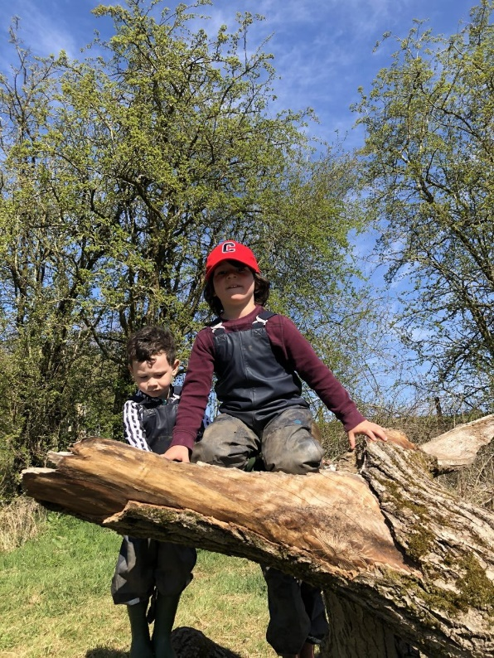
We have Level 2 Forest School trained staff and we offer regular blocks of around 10 weeks to small groups of children. We use local wooded and water sites and the experience offers children the opportunity to work as a team, challenge themselves, become more self-aware and enjoy the natural world.

Learning and Pedagogy

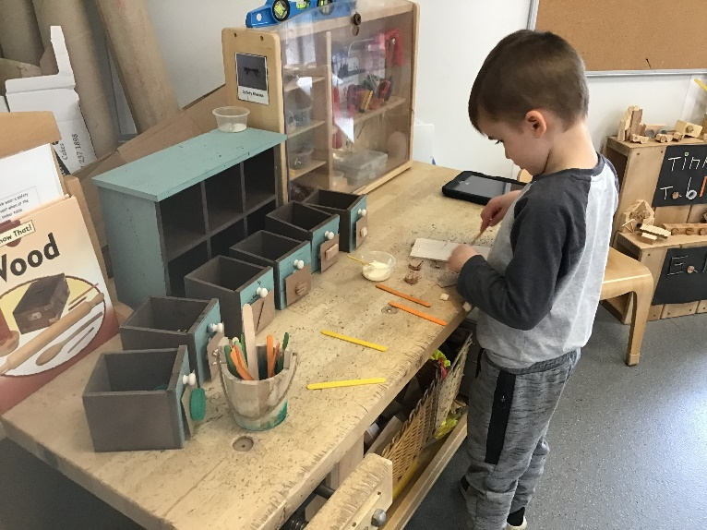
At Cart Mill Family Centre we are proud of our approach to children’s learning. I, the head teacher, feel strongly influenced by my considerable time spent in the study and practical application of early years education, and in particular the work of Loris Malaguzzi , Founder of the Reggio Emilia Schools in Italy. He believed in the natural creativity that children possess and called it “The 100 Languages of Children” whereby children have a hundred symbolic languages, including drawing, sculpting, dramatic play, writing, and painting which are used to represent children’s thinking processes and theories. As children work through problems and ideas, they are encouraged to depict their understanding using many different representations.

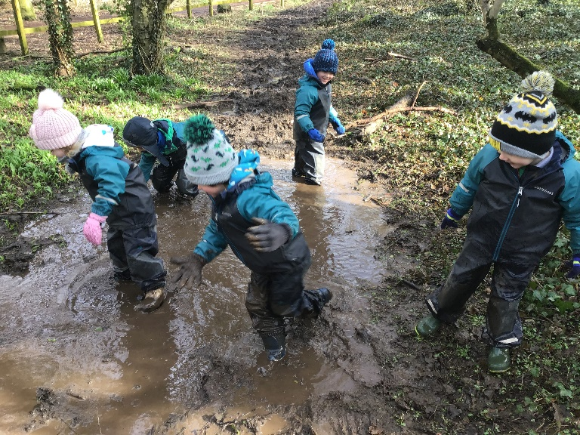
We aspire to see the hundred languages of all our children by creating a learning environment, indoors and outdoors, that supports creativity through the use of natural resources and real world play objects. Our Educators are tasked with assisting children in their creative journeys through thoughtful observations and careful interventions that enable children to reach their creative learning potential.
This strong pedagogy supports children to experience the early level of Curriculum for Excellence. Pedagogy is about the interactions and experiences which support the curriculum and the process of how children learn. This is inseparable from what young children should learn - the content of the curriculum.

Early Learning and Childcare
The curriculum frameworks we use in Scotland are Curriculum for Excellence (Early Level), and Pre Birth to Three. For information on how the curriculum is planned and provided in our centre, the Education Scotland website listed below may be useful.
Learning begins at birth and continues throughout our lives. Scottish Government education strategy, and the curriculum frameworks that deliver it, recognise that learning is lifelong, and are designed to help learners develop the skills they need for learning, life and work in an ever-changing world.

https://education.gov.scot/

Child’s Learning Journey
As soon as your child comes to our centre, they will begin to collect a record of learning experiences they take part in. This is called their Learning Journey. We would encourage your child to share this with you and there will be times when we will specifically ask for your comments on what your child’s achievements are at home so that this information can be added to give a fuller picture of your child’s learning and achievements.
The children use their journeys to reflect on what they have learned and also to plan with staff what their next steps in learning will be. These are available for you to see at any time. Ask your child about their Learning Journey!


Transitions
From Home to our Centre
We currently offer the option of a transition visit within the centre or a home visit. A member of the Senior Leadership Team will call new parents/carers a couple of weeks in advance of their child starting with us to discuss their preference. During this call, we will introduce ourselves, tell you a little bit about our centre and answer any questions that you may have about the transition process. We will also arrange a home visit or a play date for your child, making it a time that you can come along too. You will be sent all of our paperwork digitally for you to complete at home and return to us.
On your initial visit to the centre, we will introduce you to staff and take you on a tour round all of the playrooms. We want you both to experience all of our centre and allow your child to explore. You and your child will meet the member of staff who will be the key worker. During your first few weeks you will be given a learning journal that you and your child will decorate together and we ask that you include some pictures and stories from home.
Each child is an individual and that is how we approach the first day. We will always be guided by you as you know your child best. Parents and carers are always made welcome in our centre if this helps a child to settle. We will call you 2 weeks after your child has started to ensure that the transition has gone well and to answer any questions you may have. Your child’s key worker will call you from time to time to update you on your child’s progress and again to answer any questions you may have.

From our Centre to School

By the time your child is getting ready to leave us to take the next step on their learning journey to primary school, we will support this transition. Please feel free to ask us any questions regarding this transition at any time. However there will be opportunities throughout each term for you to talk to your child’s key worker.
The primary schools within our Williamwood Cluster are Carolside, Busby and Netherlee. We also work with other schools including St. Joseph’s, Kirkhill, Carlibar and Eaglesham during transition times.
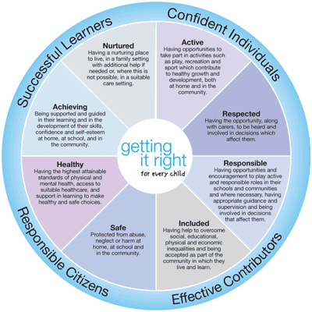
GIRFEC – Getting it Right for Every Child
GIRFEC is the national approach in Scotland to improving outcomes and supporting the wellbeing of our children and young people by offering the right help at the right time from the right people. It supports them and their parent(s) to work in partnership with the services that can help them.
http://www.gov.scot/Topics/People/Young-People/gettingitright
In basic terms, this means that as a centre for Early Learning and Child Care, at Cart Mill we are fully obligated and committed to getting it right for your child. We welcome your input and involvement at any time and look forward to working together with you to ensure the best outcomes for you and your family.
Health & Wellbeing
Wellbeing
No matter what the age of the child from babyhood onwards, health and wellbeing is the principal driving force behind children growing up and learning. The wellbeing indicators of GIRFEC, for children to be safe, healthy, achieving, nurtured, active, respected, responsible and included are implicit in the early learning we provide in our centre. It is also well known that a healthy diet and regular physical exercise are fundamental for a healthy childhood and to support brain development and physical development.
Nut & Kiwi Free
We are a nut and kiwi free centre. Please do not give your child nut or kiwi products for snacks or drinks.
Allergies and Medical Conditions
Please speak to a member of staff if your child has an allergy or medical condition as soon as you can. We do have forms for you to complete when your child starts with us but this information helps us to plan effectively for your child so that they make a smooth transition.

Healthy Snacks and Hot Lunches
We are a health promoting centre and as such we will only provide children with healthy snacks and drinks. Our snacks will consist mainly of fruit but we will develop a varied snack menu in consultation with the children. At snack times we will provide children with water or milk to drink.
The children aged 3-5 years are entitled to a hot lunch and so are some of our 2 year old children. The lunches are prepared by our cook, Louise, and consist of two courses. The lunch menu is displayed in our window and is available on our website
https://blogs.glowscotland.org.uk/er/cartmill/lunches/
Child Protection
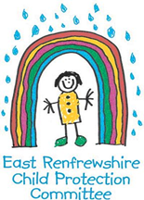
At Cart Mill Family Centre we take the care, welfare and protection of our children very seriously. We believe all children have a right to feel safe within the centre, home and community. Within our centre we strive to provide a safe, secure and nurturing environment for our children, this promotes inclusion and achievement. All education staff have a statutory and professional responsibility to take action if we have reason to believe a child is suffering, or is at risk of abuse.
Our child protection policy and procedure sets out what we will do if we have reason to believe a child is being abused or is at risk of abuse, either within the home or the community. These policies are designed to ensure that children get the help they need when they need it.
Every staff member undergoes a minimum of one child protection training activity every session. Many of our staff are more extensively trained in specific areas of child protection to support and identify potential child protection concerns.
The centre operates a multi-agency Joint Support Team to ensure that the best possible supports are available to children when they need them.
“Procedures and guidance cannot in themselves protect children; a competent, skilled and confident workforce, together with a vigilant public, can. Child protection is a complex system requiring the interaction of services, the public, children and families. For the system to work effectively, it is essential that everyone understands the contribution they can make and how those contributions work together to provide the best outcomes for children. Everyone working with children and their families, including social workers, health professionals, police, educational staff, voluntary organisations and the third sector, as well as members of the community, need to appreciate the important role they can play in remaining vigilant and providing robust support for child protection.”

(National Guidance for Child Protection in Scotland, Scottish Government, 2014)

All staff in Cart Mill Family Centre have a responsibility to:
- Ensure all children are protected and their needs are met.
- Be familiar with our child protection procedures and guidance and implement those procedures promptly when there are concerns related to the care and welfare of a child.
- Provide a supportive ethos in which children’s voices are listened to and acted upon
- Help children protect themselves by providing appropriate learning experiences within our health and wellbeing curriculum.
- Share information with other agencies which is of benefit to a child’s wellbeing.
- Contribute to assessment and recording of all child welfare and child protection concerns, using a record of concern and a chronology of significant events.
- Actively participate in annual training on child protection.

Within our centre we strive to provide a safe, secure and nurturing environment for our children which, promotes inclusion and achievement. All staff in Cart Mill Family Centre have a statutory and professional responsibility to take action if we have reason to believe a child is suffering, or is at risk of abuse. Our full Child Protection policy is available on request. The Child Protection Co-ordinator for our centre is Angela Kerr, (Acting) Head Teacher, supported in this role by Depute Head of Centre, Val MacLean.

Please do not hesitate to speak to any member of our staff if you ever have any concerns about your child’s or any other child’s safety or health and wellbeing, or suspect or know of a child who could be at risk of abuse and neglect. Or alternatively please contact staff at one of the following numbers:
Social Work: 0141 577 3003
Police Scotland: 101
Social Work Out of Hours: 0300 343 1505

Other Useful Information
Opening Times
Our Centre is open 48 weeks of the year from 8am to 6pm.
Contacting us if your child is absent
If your child is unable to attend our centre for any reason please telephone (0141 570 7560) or email (schoolmail@cartmill.e-renfrew.sch.uk) to let us know.
Complaints
Should you ever feel the need to make a complaint about our service please speak to the Head Teacher, Angela Kerr, or in her absence our Depute Head of Centre, Val MacLean or to one of the members of the Senior Leadership Team who will be more than happy to help deal with your complaint. We provide a high-quality service but we do understand that there may be times when things go wrong.
There is more information about the East Renfrewshire Council Complaints Policy at the link below.
https://www.eastrenfrewshire.gov.uk/make-a-complaint
Arriving and Leaving
On your arrival at our centre please press the buzzer “office” at the front door and you will be welcomed in to the centre. We would love you to bring your child into the playroom to their peg but we understand this may be unsettling for some. Your child’s peg will be located in one of the two cloakroom areas which your child’s key worker will show you. Staff will always be on hand to meet and greet the children as they enter the playroom and to make them feel welcome. When you arrive to pick up your child, please press the buzzer gain and let us know who you are here to collect. We will welcome you in to the centre to greet your child. If you require a friend or relative to collect your child who is not on your pick up list, please let us know in advance as we will not release your child unless we have your permission.
Security
We have secure entry into the centre and our internal doors to the playrooms are also secure and require a staff fob for entry. Our garden gates have multiple locks at adult height. These measures ensure the safety of your child at all times. Think SIMOA! For more information on SIMOA, please ask our children, staff or see the leaflet in reception.
Children’s Fund
We ask parents and carers to give a small donation each week, which allows us to provide additional experiences for the children. This is our main fundraising focus and means that the children can bake, make playdough and create models using wood and other materials that we need to buy. We ask that you make a weekly donation of £1 and make this payment through ParentPay. We thank you very much for this support.

Play Clothes
We want all of our children to feel comfortable and ready to take part in all of the experiences we have to offer. Your child will be working with glue, paints, clay and mud to name but a few of the activities offered daily, so please don’t dress your child in their best clothes. We would also ask that your child changes into indoor shoes when they arrive at our centre and has a pair of wellies that can stay with us in our Welly Shed.
Family Centred Approaches
“Family Centred Approaches is a framework created to ensure people working with children, young persons and their families share necessary skills, values and techniques to help build positive relationships and genuine partnerships helping support people fulfil their potential.”

We are delighted to hold Gold Family Friendly accreditation and we are currently working towards our reaccreditation. We welcome your involvement at any time.
Care and Welfare
There are copies of policies relating to the care and welfare of your children in our welcome area. These cover changing of children’s soiled or wet clothing including nappy changing, safe in the sun and infection control. If you have any questions about this please ask a member of staff.
As a care service we are regulated by the Care Inspectorate. This means that our service is regularly inspected to make sure we meet the right standards.
We were inspected in 2019 and we were awarded 1 Excellent and 3 Very Good grades. There is a copy of our inspection report on our website.
Contact details for Care Inspectorate:
Phone: 0345 600 9527
E-mail: enquiries@careinspectorate.gov.scot
Website: http://www.careinspectorate.com/index.php/about-us

Support for Children and Families
As a centre we work closely with our colleagues from Social Work and Health to promote the best outcomes for your child. Our Joint Support Team brings the professionals together including our Educational Psychologist so that we can work together to find the best possible support for individual children appropriate to their needs.
Speech and Language Therapist – Karen Crooks
Educational Psychologist – Jennifer Speck
Health Visitor – Various
Social Worker – Request for Assistance Team
Psychology of Parenting Project
The Psychology of Parenting Project (PoPP) is aimed at improving the availability of high-quality evidence-based parenting programmes for families with young children who have elevated levels of behaviour problems. PoPP courses are currently running across East Renfrewshire. Within our centre you can speak to your child’s key worker, or Val MacLean, Depute Head of Centre. The link below will take you to our website for more information on the PoPP programme.
https://blogs.glowscotland.org.uk/er/cartmill/parent-information/support-for-parents/

Family First
Family First is also available to our families. They have a resource page with a wealth of support available via local and national organisations as well as helplines and programmes for all families. Please speak to Val MacLean or click on the link for more information regarding Family First:
https://www.eastrenfrewshire.gov.uk/family-first-information-resource

Centre Policies
We have a number of policies available to read on our website, including:
- Breast Feeding Policy
- Child Protection Policy
- Communication Policy
- Complaints Policy
- Confidentiality Policy
- Door Policy
- Management of Medication Policy
- Nappy Changing Policy
- Parent Involvement Policy
- Prevention & Control of Infection Policy
- Promoting Positive Behaviour Policy
- Safe in the Sun Policy

Continuous Improvement
As a centre we are continuously striving to improve in order to provide your family with the best service we can and “Get it Right” for your child. In order for us to do this effectively it is important that we regularly consult with you on certain aspects of our provision. We may ask you to complete a questionnaire or give us some written feedback in the form of an evaluation form. Your co-operation with this is much appreciated and your comments valued.

Improvement Plan
There is a copy of our current improvement plan in the welcome area and there is a parent friendly one page synopsis of our planned improvements for the year on our website

Standards and Quality Report
There is a copy of our current standards and quality report in the welcome area and on our website. You will be able to read about our achievements over the past year and the areas that we are continuing to work on to secure further improvement.
Equality & Inclusion
It is never too early to promote equality, tackle stereotyping and discrimination, and encourage and promote children to be themselves and reach their potential. We all have a responsibility to put equality and inclusion at the heart of the work within our centre.

Cart Mill Family Centre aims to:

- Recognise the impact of discrimination, poverty and social inequalities on children and families.
- Recognise the importance of what is learned in childhood and how this lays the foundation for a more just and equal society.
- Value diversity and difference – this includes differences in identities, cultures, beliefs, abilities and social practices.
- Challenge negative labels and attitudes.
- Think about the ways in which we work with our children and their families to ensure that we meet the needs of all.

“No one is born hating another person because of the colour
of his skin or his background or religion. People must learn
to hate and if they can learn to hate, they can be taught
to love, for love comes more naturally to the human heart
than its opposite.”
Nelson Mandela (1994)
Cart Mill Family Centre has clear guidelines and procedures for dealing with incidents of inequality, as advised by the Education department. We are also a Rights Respecting Centre and started our journey at Bronze level in August 2021. We encourage that any concerns you have be raised with us. Our Equalities Co-ordinator is Angela Kerr, Head Teacher.

Data Protection
Data Protection Act 1984/GDPR 2018
Information on parents and guardians is stored on a computer system and may be used for teaching, registration, assessment and other administrative duties. The information is protected by the Data Protection Act 1984 and may only be disclosed in accordance with the Codes of Practice. For further information please contact the centre.
The general data protection regulation (GDPR, 2018) has replaced the Data Protection Act. It was the biggest overhaul of data protection legislation for over 25 years, and has introduced new requirements for how organisations process personal data.
We will update our statement to reflect the changes that we are implementing as a result of the new law in due course.

Contact Us:
Cart Mill Family Centre
Head Teacher: Angela Kerr
Newford Grove
Clarkston
G76 8QZ

Tel: 0141 570 7560

Email: schoolmail@cartmill.e-renfrew.sch.uk

Website: https://blogs.glowscotland.org.uk/er/cartmill

