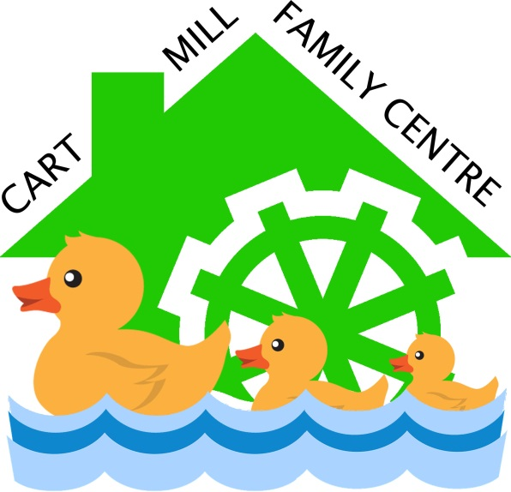

The children have talked about what rules we need to have in our centre so that they can play happily.
This is what the children have signed up to:

Cart Mill Children’s Charter

We look after our toys and tidy them up.
We say please and thank you.
We are kind to others and we show them respect.
We listen to others and share our ideas.
We are patient and wait for our turn.

