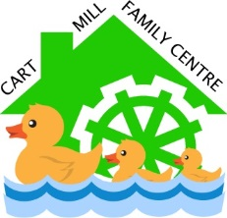
Cart Mill Family Centre
Nappy Changing Policy
Prepare Area
Wash Hands
Use Sterex + provided to sanitise the changing station and waterproof changing mat. (Do not use if torn) before use.
Wash Hands
- Put on white plastic apron and disposable gloves.
- Use child’s own wipes and nappy/pull-up
- Double bag soiled nappy/pull-up and used wipes. (Tie bag to seal)
- Put soiled clothing into a plastic bag – double bagged.
- Label the bag with the child’s name, date and time of change. Store in an individual, labelled, plastic container in the changing area.
- Register child’s name, time and date of change on daily record sheet in changing area.
- Remove apron and gloves.
- Dispose into yellow bin provided.
Wash Hands
Further Preparation
- Put on fresh disposable apron and gloves.
- Put on clean nappy/pull-up.
- Dress the child.
- Take the child back to the playroom.
Clean Area
- Use Sterex + provided to clean changing area.
- Dispose of used PPE into yellow bin.
Wash Hands
Wash Hands again once entering the playroom.
For further information on nappy changing see: nappy-changing-guidance-2024.pdf (careinspectorate.com)

