Cart Mill Family Centre
Breastfeeding
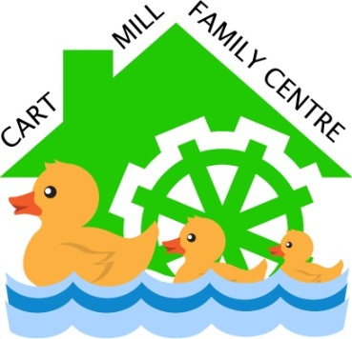
Rationale

At Cart Mill Family Centre we have a strong focus on families and relationships. We appreciate that breastfeeding is a natural way to feed an infant and we will promote and support breastfeeding within our centre. When children are learning about the cycle of life and new born babies, we will discuss “how infants are fed” ensuring every child has opportunities to understand the benefits of infants being breastfed.
Our children learn through play. They are encouraged to explore and to participate in role play. Equipment will be able promote positive images of breastfeeding for example, books, jigsaws, in rhymes and other learning and play that children participate in.
We work closely with other with other professionals to establish an ethos of mutual trust and openness and to ensure that all skills and expertise is respected to support the service we provide to the children and their families.
Breastfeeding is the healthiest way to feed a new infant and young child. It is recommended for around the first six months of a baby’s life. After this period of time a baby will be introduced to other foods along with breast milk.
Breastfed babies tend to have:
- Lower instances of infection
- Less occurrences of allergies
- A healthier body weight
- Less chance of developing eczema
Breastfeeding has a positive effect, the longer an infant is breastfed, the greater the protection from infection the child will receive.
www.breastfeeding.nhs.uk
According to the Breastfeeding etc. (Scotland) Act 2005 it is an offence to prevent or stop a person in charge of an infant from feeding them in a public place. This means that any person should be able to feed an infant when required without the fear of interruption or criticism.

Objectives

At Cart Mill Family Centre we promote the benefits of breastfeeding by:
- Adhering to the Breastfeeding etc. (Scotland) Act 2005, Equality Act 2010 and East Renfrewshire Council policy guidelines.
- Supporting employees returning to work who wish to continue to breastfeed their baby.
- Providing a welcoming environment for breastfeeding families displaying UNICEF’s posters throughout the family centre.
- Ensuring staff welcome families by helping them to feel comfortable and supported to breastfeed in an area suitable to them, without disturbance and with the option of privacy if preferred.
- Supporting breastfeeding staff/centre users by helping mother and baby to feel relaxed.
- Maintain a minimum of 80% staff attending Breastfeeding Welcome training thus enabling staff to promote and support breastfeeding within the family centre.
- Advertising and promoting breastfeeding support groups on notice boards throughout the family centre.
- Displaying and informing users of the benefits of breastfeeding.
- Using resources which reflect breastfeeding to develop children’s learning trough play.
All books, posters and toys will be continually reviewed by staff and where necessary will be removed and/or replaced.
- Books showing bottles being used to feed infants.
- Resources containing pictures of infant feeding bottles and items containing bottles, teats or dummies as a symbol for infants.
- Toys promoting bottle feeding.
Drafted: 29th March 2016
Adopted: April 2016
Review date: 28 February 2024

