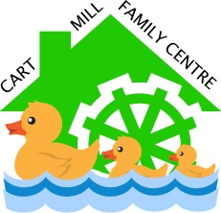
Transition to our Centre
Home or Centre Visit Policy

We extend a warm welcome to you, your child and your family and hope that we can forge a strong partnership between home and our centre right from the start.
We value your unique knowledge of your child and hope to build on their experiences from home as they begin their learning with us.
Initially we will contact you via email or telephone call to discuss with you the choice of either a home visit or visit to the family centre; whichever suits you and your family best, and we will arrange a time for this to happen.
During your chosen visit we will:
- Use a comfortable space where you can meet a member of the senior leadership team and your child’s keyworker.
- Take time to complete your child’s personal plan. This will help settle your child through engaging them in some of their favourite experiences from home.
- Talk about snack, lunch and what items to bring along on your child’s start date.
- Invite you to view our family centre environment, introduce you to the staff team and allow time for you to play with your child in our centre.
Your child’s keyworker will:
- Spend some time playing and establishing a relationship with your child.
- Show your child around the family centre and introduce them to other staff and children.
- Take a photograph of your child and prepare a coat pack.
- We look forward to your child continuing their learning journey with us here at Cart Mill Family Centre.

