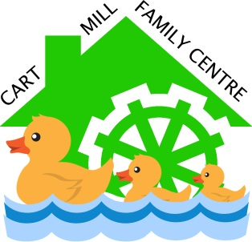
Safe in the Sun
Policy

RATIONALE

Cart Mill Family Centre values learning in the outdoors and allows children free access to the outdoor playroom all day. There is a risk during periods of hot weather that children’s skin could be damaged by the harmful rays of the sun which could lead to skin cancer in later life.

AIM

This policy sets out to protect our children from skin damage by informing staff and parents of our protocol to ensure that all children are safe in the sun. Babies and children need to have their skin protected between March and October in the UK.

When we experience a period of extended hot weather we would advise that you follow our sun protection policy stated below.

- We would ask that you apply the first coat of sun cream to your child before you bring them to our centre in the morning or afternoon. Sun cream should have a factor of at least SPF30 and protect against UVA and UVB rays.
- Please leave sun cream with us for your child which has their name on it.
- Staff will then apply further coats if and when required depending on the heat of the sun and the length of time spent outdoors or if they stay for an extended day.
- We would ask that your child always has a sun hat (one with a wide brim and neck protection is ideal) and at least a short sleeved T-shirt to protect their shoulders from the sun.
- During exceptional heat or where there is a weather warning, children will remain indoors during the hottest part of the day.
- Please remember a water bottle so your child can keep hydrated throughout the day.

Following this guidance will ensure will ensure that children can continue to enjoy their outdoor experiences.

For more information on sun safety click this link to the NHS website Keeping your baby safe in the sun - NHS (www.nhs.uk) (accessed July 2022)

Adopted: 16th April 2016
Reviewed: July 2022

