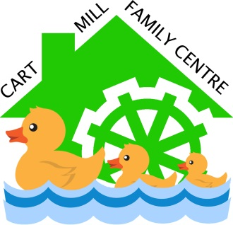
Cart Mill Family Centre
Forest School Communication Strategy
RATIONALE

Cart Mill Family Centre values Forest School and supports good communication amongst staff who are assisting in our Forest School programmes and for all other parties such as children and their families.

Aim
The aim is to ensure good lines of communication is kept in order to provide the best care and learning for all individuals involved. It is also Cart Mill’s responsibility to furnish families with the knowledge and understanding of the Forest School programme their children are involved in, the reason behind it and how the child is developing throughout.
Practice
For assisting/cover staff.
- Handbook will be given to all staff before going out to the forest for them to read and is accessible at any time.
- Observations will be completed and place into the forest School folder after each session.
- Staff will feed back to key workers verbally on the return to the family centre for feedback to parents/carers.
- Staff can inform keyworkers of observations made at the end of the block
For Parents/ Carers
- Parents will be made aware of the staff who deliver forest schools via X formerly Twitter and the blog.
- An information night will be held for parents wanting more information before each block starts, this is a good time for answering questions.
- Parents can ask key workers or forest school staff at any time how their child’s development is coming on during their block.
Updated August 2023 Review by August 2024

