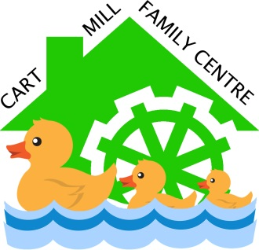
Cart Mill Family Centre
Door Policy

Rationale
Cart Mill Family Centre aims to provide a positive ethos and very welcoming environment for all stakeholders. A door entry policy is essential to support the health, safety and wellbeing of all children.

- If a child is absent and the parent/carer has not informed the family centre of a reason a prompt telephone call will be made to the family home/carer. (Guidance from Standard circular 57)

- Senior Clerical Officer is responsible for completing Fire Register, in her absence and out with her working hours, Head Teacher/Depute Head of Centre/Senior Child Development Officer will take over this responsibility.

- Wherever possible a member of the leadership team will welcome families at the front door where they will be invited into the centre.

- Only Cart Mill staff will open the door to families and any other visitors during family centre sessions. Please do not hold the door open for others, we understand this can seem rude but it keeps everyone safe.

- Staff in playrooms will welcome children in to each area.

- All visitors must sign in to Visitor Book. (for Fire Register purposes)

A member of the leadership team will advise supply staff and students of routines/procedures.

Any support team members must inform staff when working with individual children and where they will be in the building.

During any parent participation event, the door must be supervised by a staff member at all times.

In the event of a parent/carer running late, a member of the Senior Leadership Team will wait with a child until they are collected.

If children are out on a bus trip and later back than anticipated – a member of the leadership team will apologise to parents for the delay, allow the children a couple of minutes to come back into the Family Centre to be signed out before the parent/carer collects.

All staff have a responsibility to ensure that children are handed over to a parent/carer or designated adult (identified on the sign in sheet). If an unknown adult arrives to collect, a member of the Senior Leadership team will contact the parent/carer for advice and discuss the reasoning with the unknown adult.

