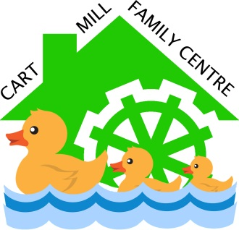
Cart Mill Family Centre
Complaints Policy

Rationale
East Renfrewshire Council’s definition of a complaint is:

'An expression of dissatisfaction by one or more members of the public about the Council’s action or lack of action, or about the standard of service provided by or on behalf of the Council.'

A complaint may relate to:

- failure to provide a service
- inadequate standard of service
- dissatisfaction with Council policy
- treatment by or attitude of a member of staff
- disagreement with a decision where the customer cannot use another procedure (for example an appeal) to resolve the matter
- The Council’s failure to follow the appropriate administrative process.

This list does not cover everything.

Aim
Cart Mill Family Centre, as part of East Renfrewshire Council, is committed to being a modern, efficient organisation; responsive to the needs and views of residents, customers and visitors to the area. An important part of this commitment is ensuring that there is in place a simple, quick and effective method of resolving matters when things go wrong and also learning from any problems identified to improve the level and quality of services provided now and in the future.
Practice
For a detailed breakdown of this policy, employees should refer to East Renfrewshire Council Complaints Handling Procedure:

“This document explains to all employees our revised procedure for complaints handling in East Renfrewshire Council. The changes have been introduced to comply with new statutory guidance issued by the Scottish Public Services Ombudsman (SPSO). The document sets out the definition of a complaint, how complaints should be handled, recorded and by whom and the response timescales within our internal two stage complaints process.
This document can be accessed via the Complaints Information Hub on the Council’s intranet where you can also find related links to other good practice information on complaints handling published by the Complaints Standards Authority at the SPSO.

A summary document explaining our revised procedure has been produced for customers and is available on the Council’s website. A summary document for employees is also available on our intranet. “

