***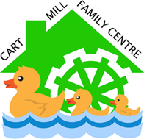*Cart Mill Family Centre**

**Cart Mill Café Mealtime Policy**

‘Meals and snacks should be nutritious and served in a relaxed, calm, pleasurable and safe environment. The environment, location and setting should be well planned and promote a sense of belonging and support interactions.’ (Care Inspectorate, 2022).

**What does a quality mealtime look like at Cart Mill?**

At Cart Mill we ensure that our mealtimes incorporate the following:

* A relaxed and unhurried environment
* Equality and inclusion
* Promoting children’s choice and voice
* Practitioner support for children aged 2-5
* A home from home environment

The children make choices around the fruits and vegetables they would like at snack time. The children help to select, wash and chop our snack and show independence by self-selecting what they would like to eat. Preparation of food should be child focused and take into account the age and ability of children and young people to chew and digest their food. Children are encouraged to tidy up after snack and wash their dishes in the sink. We have a rolling snack from 9,30-10,30 to allow children to come for snack when they are ready to and repeat this each afternoon from 3.00pm.

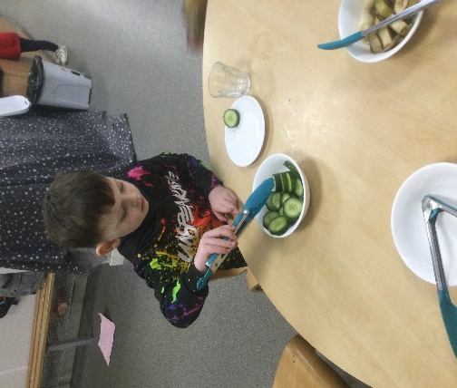

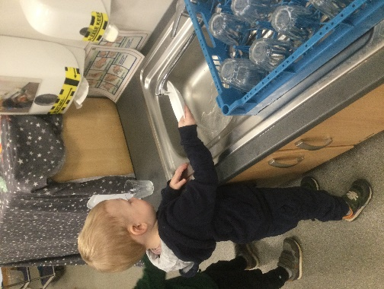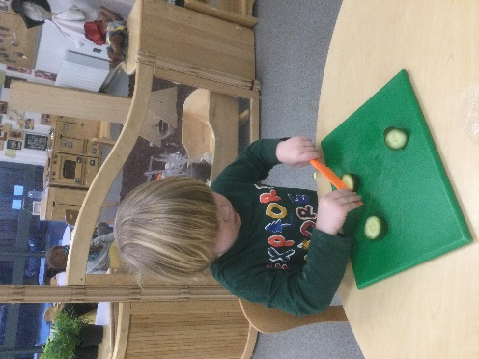

We incorporate baking into snack times too, to offer a wider choice to all our children. This ensures that children and young people in our care are at the centre of our practice (GIRFEC, 2008). We believe that food should not just be seen as a routine of the day but instead used as a resource for learning and having fun. Cooking with children provides a variety of learning and social experiences; e.g. weighing and measuring, learning about safety and washing hands, learning to share and work together as well as celebrating success (Setting the Table, 2014).

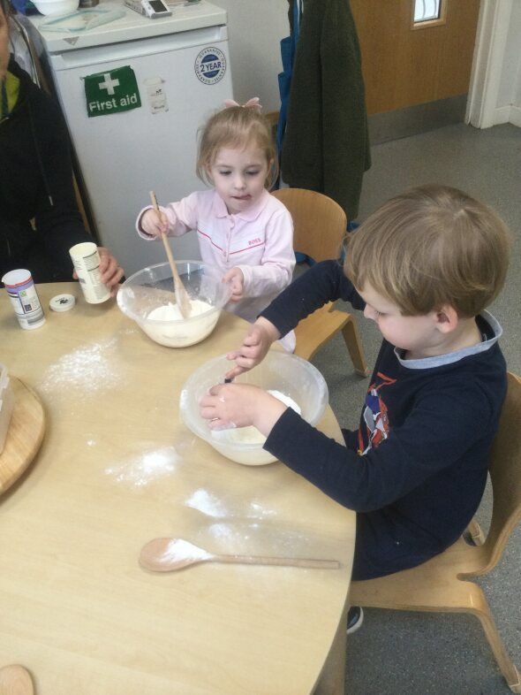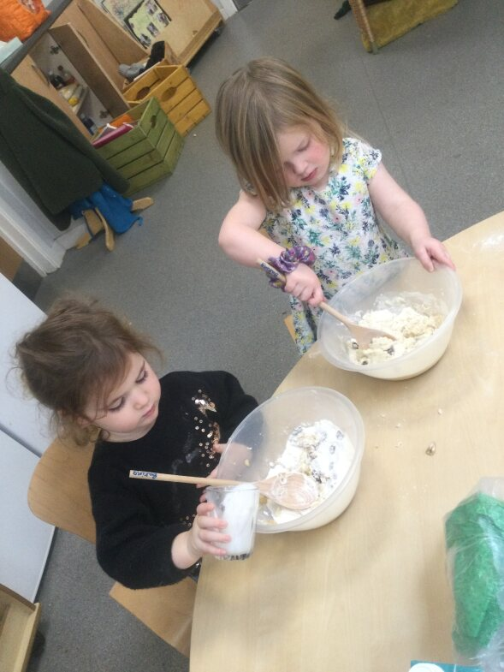

At lunch time, within Cart Mill, the children work together with a keyworker to set up the lunch tables. This encourages independence and promotes numeracy, communication and social skills. We have a mixture of hot lunches and packed lunches, with all children sitting down together to create a positive social experience.

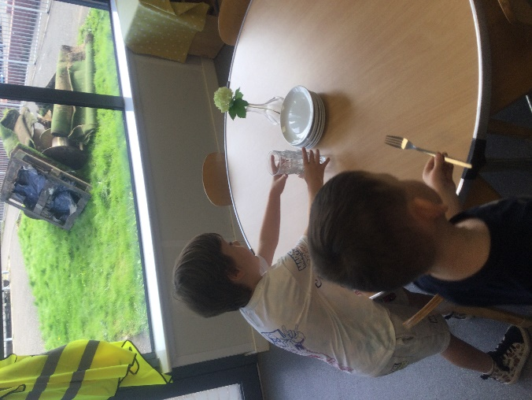

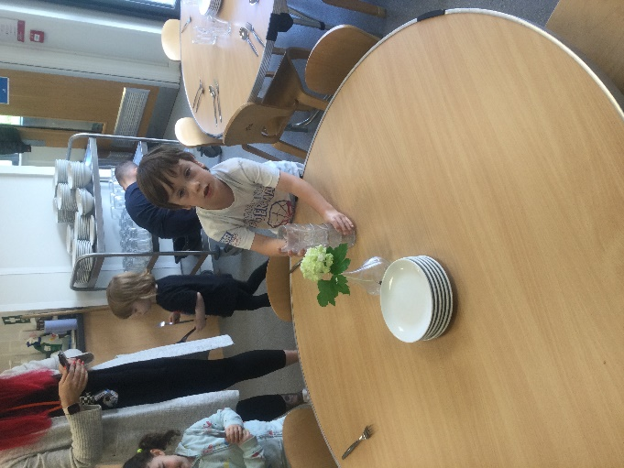

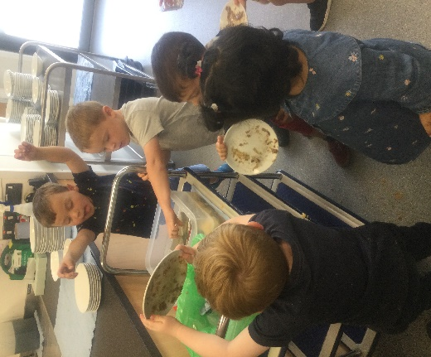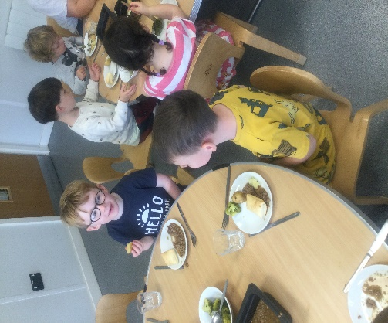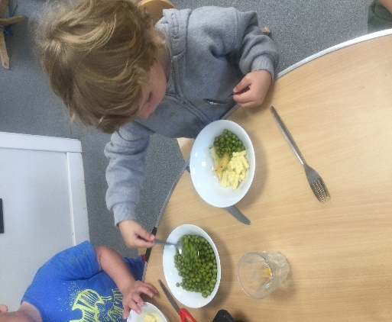Each child has their own space at the lunch table with a plate, bowl, glass and cutlery available to them. Each table is joined by an adult who supports the children to have a calm and safe lunch time experience. The food is placed at the centre of the table, encouraging children to serve their own lunch and then pass it to the child sitting beside them, creating a home-like atmosphere.

The lunch menu follows a 3 week rotation, offering children a variety of soups, fruit, vegetables and a hot main course. The adults have the opportunity to eat alongside the children to model good eating habits and support children to achieve positive health and wellbeing outcomes (Pre-birth to Three, 2010) (Curriculum for Excellence, 2004).

When children start at Cart Mill, parents are consulted to ensure all dietary and lifestyle requirements are taken into consideration ensuring that suitable meals are provided for all children.

Review date January 2025