Forest School

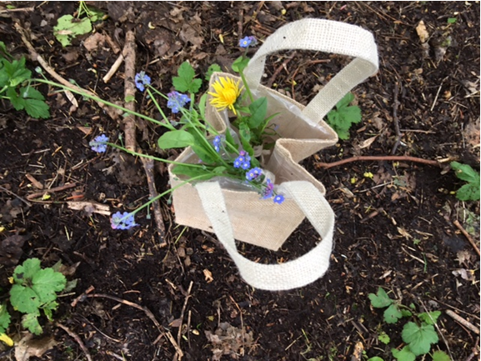

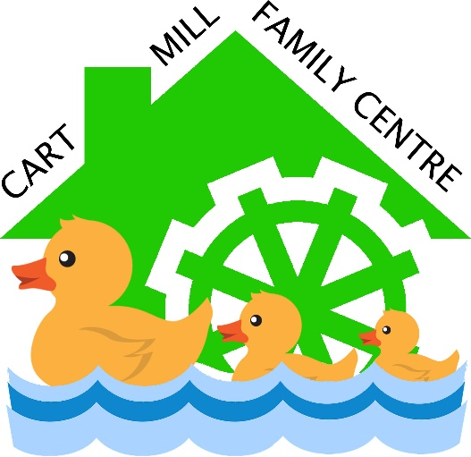

Parent & Carer Information
What is Forest School?

Forest School is a Classroom without walls, it is a learning environment with no limits. Forest school is where children can rightfully play and use nature and themselves as their educator, with staff being the assistant in the background.

Forest Schools is NOT a treat, it is an outdoor learning experience which provides a naturally stimulating environment that is key to children’s development.

What is The Ethos of Forest Schools?

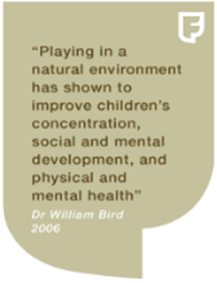
“The ethos of Forest School is based on a fundamental respect for children and young people and for their capacity to instigate, test and maintain curiosity in the world around them. It believes in children's right to play; the right to access the outdoors and a woodland environment; the right to access risk and to explore the vibrant reality of the natural world; and the right to experience a healthy range of emotions, through all the challenges of social interaction, to build a resilience that will enable continued and creative engagement with their peers and their potential. “

- Richard Louv – Last Child in the Woods “Saving our children from nature deficit disorder”.

”Supposing a tree fell down, Pooh, when we were underneath it?”

“Supposing it didn’t!” said Pooh after careful thought.
Piglet was comforted by this.” A A Milne

Our Forest School Practitioners

- In training currently for her Level 3 Forest School Leader Training - Sharon McKenna – Head Teacher

- Val MacLean has the Level 2 Forest School Assistant qualification with some other staff working towards this.

Risk Assessments

The site will be fully risk assessed. Each week there will be a dynamic risk assessment carried out by staff and children which will record any changes on site.
There will also be risk assessments for each activity carried out as part of the forest school program.

Our children will be involved in risk assessing on site, here are some of the questions we will ask them to prompt their thinking:

- How high is too high?
- Do you feel safe?
- If you don’t feel safe, why not?
- What do you think will happen?
- Which way is the safest way to walk, run, climb etc.?
- Why not try it and see?
- Do you think we need to make a boundary to keep us safe?

First Aid

At least one member of staff is required to hold an outdoor First Aid Certificate. Currently Sharon McKenna, Val MacLean and Stephanie MacPherson hold Outdoor First Aid certificates.

First Aid kit is carried as part of our daily operating procedure. Staff will be aware of any children’s health issues or additional support needs, and will carry appropriate medication/ pastoral care equipment.

First Aid Kit supplies

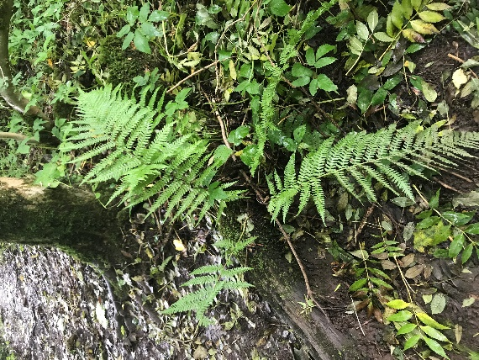
- Plasters
- Bandages
- Scissors
- Ice pack
- Burns gel
- Eye pad
- Saline water
- Gloves
- Antiseptic wipes

Accident/Emergency Procedure

In the event of a minor accident, First Aid will be administered by a certified first aider.

If it is a serious injury first aider will contact emergency services in the first instance, then the Head Teacher who will in turn alert the child’s parent/guardian. Whilst the other staff will remain with other children and ensure their wellbeing is monitored and cared for.

If the child has to be taken to hospital, one member of staff will accompany the child and the other member of staff will remain with the other children and telephone the centre for additional support.

In the event of a child having a specific medical procedure in place this will be adhered to in the first instance, being aware of another user’s wellbeing.

Cancellation Procedure

It is very rare that a Forest School session should be cancelled, but if unfortunately this did have to happen, the children will still be taken to our nursery garden and can have a Forest school session on our own site. Parents will be informed of this as soon as a decision is made via face to face communication at pick up or drop off or via phone or email.

Forest Schools will not be cancelled due to weather unless it is a risk to the individuals, the risk is highest when there are strong winds and freezing conditions. Otherwise our forest school will continue.

Staff will monitor the weather and if anything changes Forest school may be done the following day or later the same day.

Children will be made aware of why it is unsafe for them to go into the forest and a discussion will be had around this encouraging the children to think of reasons as to why it could be a hazard.

Forest Schools also may have to be cancelled in the unfortunate event of a staff shortage. This would mean that no qualified Forest School Practitioner would be available, and staff are all regarded to stay at the center to keep ratio regulated.

Forest School Kit

We will provide your child with a waterproof suit and a waterproof jacket with hood. We also have hats.

It would be most helpful if your child could be dressed in jogging trousers or leggings so that they have ease of movement and it is easy to pull them up and down for toilet visits. The children will be wearing their wellies so it is a good idea in the winter to double up their socks.

It is also a good idea to give your child layers of clothes for example, vest, t-shirt and jumper. This means that if they feel too warm they can reduce the layers but it will also mean that they are kept warmer in the winter.

Snacks

We will provide your child with a drink and a snack during their Forest School session.

Questions

Please do not hesitate to get in touch if you have any further questions about Forest School. Please ask to speak to Val or Sharon in person or e-mail us at

schoolmail@cartmill.e-renfrew.sch.uk

