Outdoor learning
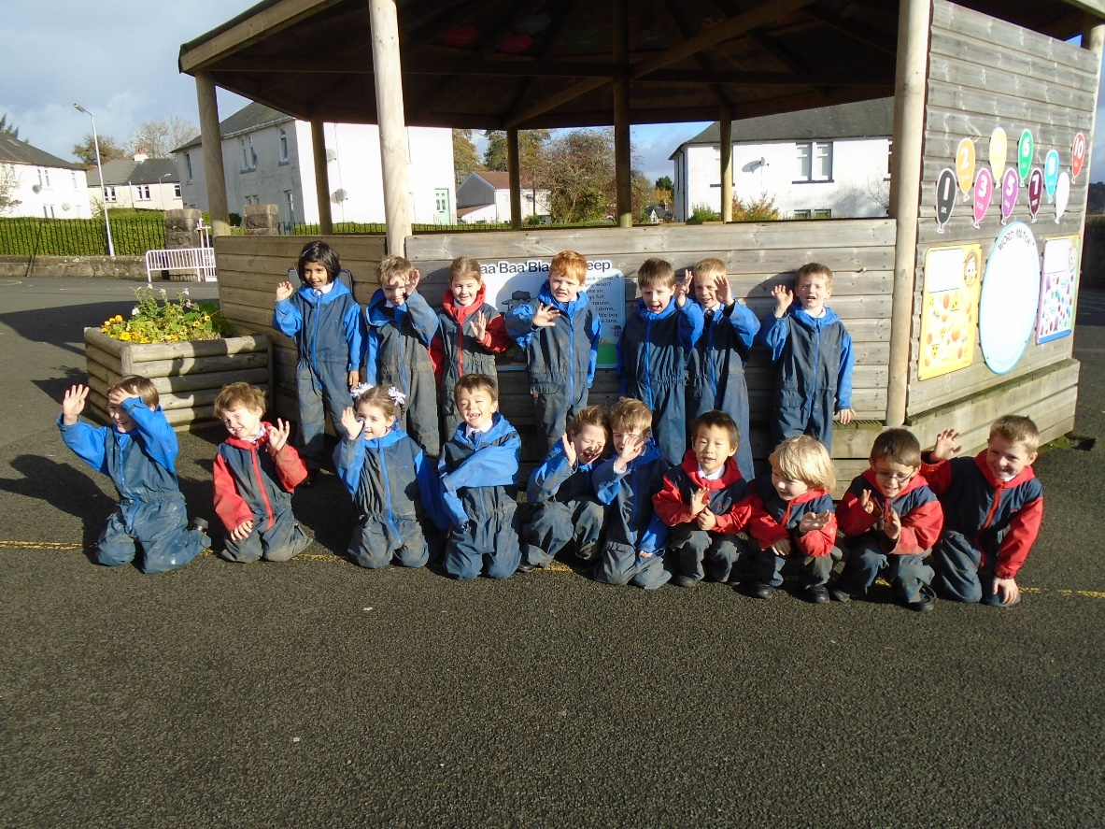

We are ready for outdoor learning!

