  Home Learning |  | Monday
Curricular Area | Who | Task
Spelling  ‘u_e’ | On my own | 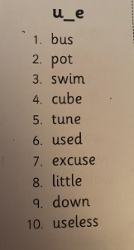  At the back of your literacy jotter please copy this week’s spelling list.  Write the title ‘u-e’ and underline.
Personal Writing  Title:  My Busy Monday | A little adult help to recap some  verbs  - a doing word | At the front of your lined literacy jotter write the date on the top lined and copy the title underneath and underline.  Write a set of instructions describing a plan of your day using:  First, Next, Then, After and Finally.  - Add a verb for each instruction you give.  e.g. First I will click the mouse to open my work on the computer.  - Remember correct punctuation!  - Highlight the verbs in each sentence.  - Draw a picture

