P2B  Homework Programme |  |  | Week beginning:  03.02.20
Curricular Area | Day | Tasks
Reading | Mon-Wed | Please choose a book of your choice as part of the First Minister’s Reading Challenge.  Complete a summary of the book and choose 2 words and clarify their meaning using the sheet provided.  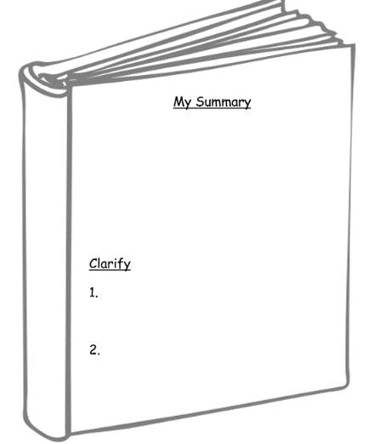
Mental Maths | Mon-Wed | Please login to your Education City account and play allocated games. Details stuck on the inside cover of diary.
Term 2 – P2 Overview

An example of tasks is listed below:

- Spelling Words (Mon-Thurs) written 3 times or an active spelling activity
- Reading Book – as per group reader
- Mental Maths Grid or Education City Games
- Seasonal tasks

***P.E DAYS – MONDAYS & FRIDAYS (OUTDOOR at the MUGA) ***

