P2B  Homework Programme |  |  | Week beginning:  25.11.19
Curricular Area | Day | Tasks
Spelling  ‘ss/zz’  ‘Days’  ‘ch’ | Mon-Tue | 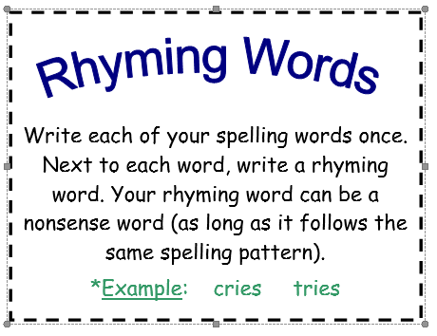  Please complete active spelling task below instead of copying words from your list three times.
Reading | Mon-Thu | Please read your group’s text over the course of the week and practise the word list.
Mental Maths | Mon-Tue | Please login to your Education City account and play allocated games. Details stuck on the inside cover of diary.
Expressive Arts | Ongoing | Continue to practise songs and narrator lines for our P1+2 festive production of ‘The Nativity’.  If you know them already – great!  Thank you
Term 2 – P2 Overview

An example of tasks is listed below:

- Spelling Words (Mon-Thurs) written 3 times or an active spelling activity
- Reading Book – as per group reader
- Mental Maths Grid or Education City Games
- Seasonal tasks

***P.E DAYS – MONDAYS & FRIDAYS ***

