P2B  Homework Programme |  |  | Week beginning:  11.11.19
Curricular Area | Day | Tasks
Spelling  ff  qu  or/au/aw | Mon | Please complete spelling task below instead of copying words from your list three times.  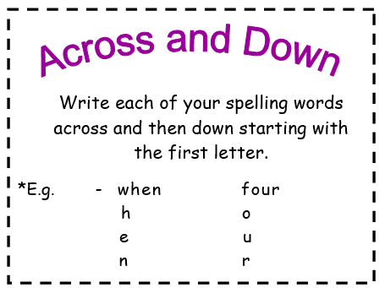
Reading | Mon-Thu | Please read your group’s text over the course of the week.
Mental Maths | Mon-Tue | Please login to your Education City account and play allocated games. Details stuck on the inside cover of diary.
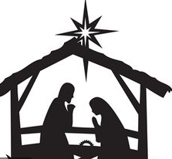  Expressive Arts  The Nativity | Ongoing | Sent home this week to practise are this year’s songs from our P1+2 festive production of ‘The Nativity’.  P2 pupils will also each have an important speaking role as the narrators of the show. Please practise your lines each day until you’re confident enough to perfom them in front of an audience.
Term 2 – P2 Overview
An example of tasks is listed below:
- Spelling Words (Mon-Thurs) written 3 times or an active spelling activity
- Reading Book – as per group reader
- Mental Maths Grid or Education City Games
- Seasonal tasks
***P.E DAYS – MONDAYS & FRIDAYS (OUTDOOR)***

