P2B  Homework Programme |  |  | Week beginning:  30.09.19
Curricular Area | Day | Tasks |  | Self-assessment
Phonics | Tue-Thu | This week please write the alphabet from A-Z once in lower case letters and once in uppercase letters. Complete as below.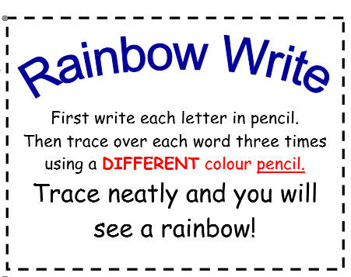
Reading | Tue-Thu | Please read your group’s text over the course of the week.  Practise words from the tricky word list.
Mental Maths  (continued)  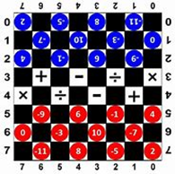 | Deadline –  Friday  4th  October | A message from the STEM Committee.  Hi, we are the STEM committee and we are setting you a competition as part of your homework to tie in with National Maths Week. You will have 2 weeks to complete.  We are asking you to design and make a maths game which you can bring into school. The whole school will then play them on the Friday.  There will be a winner from each class, who will get a prize and 50 House Points! Your game could be a board game, a ball game, card game or any other ideas you have.  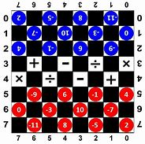  You could have a family entry if you wish or an individual entry. It is up to you! We look forward to seeing what you produce!  (STEM committee)
Term 1 – P2 Overview
An example of tasks is listed below:

- Spelling Words (Mon-Thurs) written 3 times + active spelling activity
- Reading Book – as per group reader
- Mental Maths Grid or Education City Games
***P.E DAYS – MONDAYS & FRIDAYS (OUTDOOR)***

