**Braidbar Primary School**

2 December 2019

**Nativity 2019**

Dear Parent/carer,

The children are very enthusiastic about our upcoming Christmas performance: ‘The Nativity’ and their presentation skills are improving by the day. Thank you for your support with this.

Today we would like to inform you about costumes. **All** children will be provided a costume in the form of a t-shirt and headdress by the school. However, they will **also need** to wear a **pair of black trousers or leggings** along with this to compete the costume.

The children will need these items for the performances by **Friday 6th December**.

A reminder of our performance dates:

**Monday 9th December 2019** (dress rehearsal for school staff/pupils only)

**Tuesday 10th & Wednesday 11th December 2019** (morning/afternoon performances)

Please ensure black leggings/trousers are sent to school in **a clearly labelled carrier bag** by **Friday 6th December.** Thank you.

Don’t hesitate to get in touch if you wish to discuss this further.

Yours sincerely,

C Baillie

[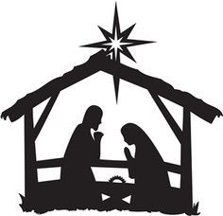](https://www.google.co.uk/url?sa=i&rct=j&q=&esrc=s&source=images&cd=&cad=rja&uact=8&ved=0ahUKEwjx2d6Z9dzQAhVpJ8AKHaqICdgQjRwIBw&url=https://www.pinterest.com/explore/nativity-clipart/&psig=AFQjCNGLydeE83dIWmGuxy_nCuH1LH3QmA&ust=1481022576590421)P2A Class Teacher