[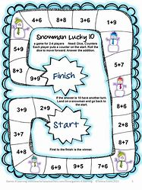](https://www.bing.com/images/search?view=detailV2&ccid=u7cR43Cv&id=67A7331D84545BA50A8A1F8F4A5C06415AAA67D5&thid=OIP.u7cR43CvG0kOWEL9RvNoWwHaJ4&mediaurl=http://1.bp.blogspot.com/-UkRzEF5EWSg/UsTLhcvOERI/AAAAAAAAB2c/-YeJueuxBts/s1600/Slide5.GIF&exph=1058&expw=793&q=maths+games&simid=608035289366465204&selectedIndex=29&adlt=strict)[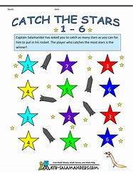](https://www.bing.com/images/search?view=detailV2&ccid=rOVDg8Fc&id=F0919DE2E716407FB3B8B42739F058E6EB3079A3&thid=OIP.rOVDg8Fcfl8ps9Qd_59OxAHaJl&mediaurl=http://www.math-salamanders.com/image-files/cool-maths-games-catch-the-stars-1-6.gif&exph=1294&expw=1000&q=maths+games&simid=608034958652408252&selectedIndex=114&adlt=strict)[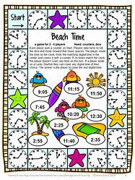](https://www.bing.com/images/search?view=detailV2&ccid=KsKIvLx0&id=271389746656FF4E24BB1672CC1543033F721C8E&thid=OIP.KsKIvLx0aMqw0uGCQuib7wHaJ4&mediaurl=http://4.bp.blogspot.com/-tAWmIvNKU7E/U5Gn_lcyuNI/AAAAAAAACRs/5ms5Zk4fY1k/s1600/End%2bof%2bYear%2bMath%2bGames%2bSampler%2b%25286%2529.GIF&exph=1058&expw=793&q=maths+games&simid=608021390875232657&selectedIndex=71&adlt=strict)

Hi we are the STEM committee and we are setting you a competition as part of your homework to tie in with National Maths week. You will have 2 weeks to complete it and hand it in by Friday 4th October.

We are asking you to design and make a maths game which you can bring in to school. The whole school will play them on the Friday. There will be a winner from each class, who will get a prize and 50 House Points. Your game could be a board game, a ball game, card game or any other ideas you have! You could have a family entry if you wish or an individual entry.

[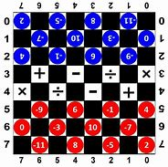](https://www.bing.com/images/search?view=detailV2&ccid=YyV4a2tk&id=80E8FC977B1F2B72F3EB2602C91F65C91C28A9EC&thid=OIP.YyV4a2tkIuXHqDHMwqrttAHaHZ&mediaurl=http://gamepedler.com/wp-content/uploads/2017/01/Integer_Damath_Piece_Setup.jpg&exph=623&expw=624&q=maths+board+game&simid=608023448143137785&selectedIndex=60&adlt=strict)

We look forward to seeing what you produce!

From Alex, Aisha and William (STEM committee)

[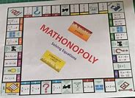](https://www.bing.com/images/search?view=detailV2&ccid=pPihou7i&id=2FE730EFA604E780667D9B74AD08CCA944B3DC4A&thid=OIP.pPihou7iJoCUwM7B1NC6nQHaFV&mediaurl=https://s-media-cache-ak0.pinimg.com/736x/22/09/de/2209dec6808db2cb56ac2cdcfea15a44.jpg&exph=432&expw=600&q=maths+board+game&simid=607990857923954919&selectedIndex=2&adlt=strict)[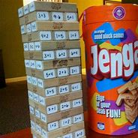](https://www.bing.com/images/search?view=detailV2&ccid=Go2iYMTI&id=DB88FDFEAC1AEEA4CE1A5F8AA82402EE5562D747&thid=OIP.Go2iYMTIt9zBTKoC-7T7HAHaHa&mediaurl=https://s-media-cache-ak0.pinimg.com/564x/a8/70/ca/a870cad73d1c12cda40f3a2be4dc3e6c.jpg&exph=564&expw=564&q=jenga+maths&simid=607999980439931745&selectedIndex=2&adlt=strict)