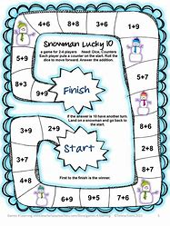
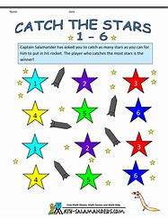
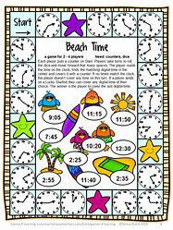

Hi we are the STEM committee and we are setting you a competition as part of your homework to tie in with National Maths week. You will have 2 weeks to complete it and hand it in by Friday 4th October.
We are asking you to design and make a maths game which you can bring in to school. The whole school will play them on the Friday. There will be a winner from each class, who will get a prize and 50 House Points. Your game could be a board game, a ball game, card game or any other ideas you have! You could have a family entry if you wish or an individual entry.
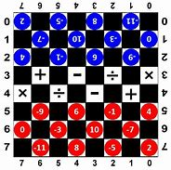
We look forward to seeing what you produce!

From Alex, Aisha and William (STEM committee)
